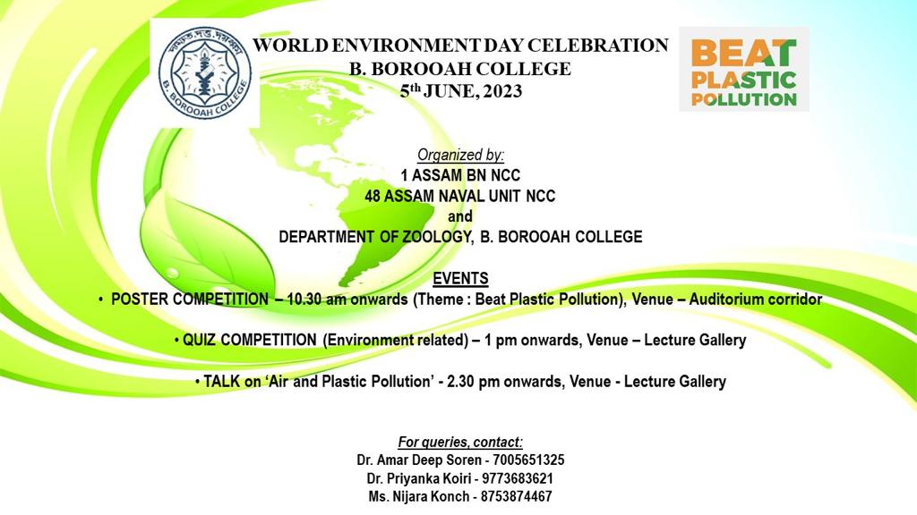
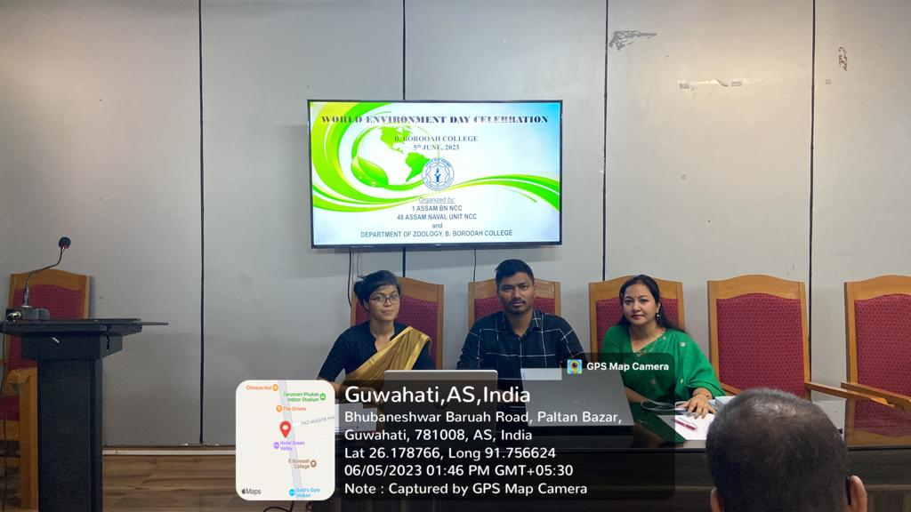
Organising team: From Left Ms. Nijara Konch, CTO, 1 Assam BN NCC Unit, Dr. Amar Deep Soren, Department of Zoology, Dr. Priyanka Koiri, CTO, 48 Assam Naval Unit, NCC.
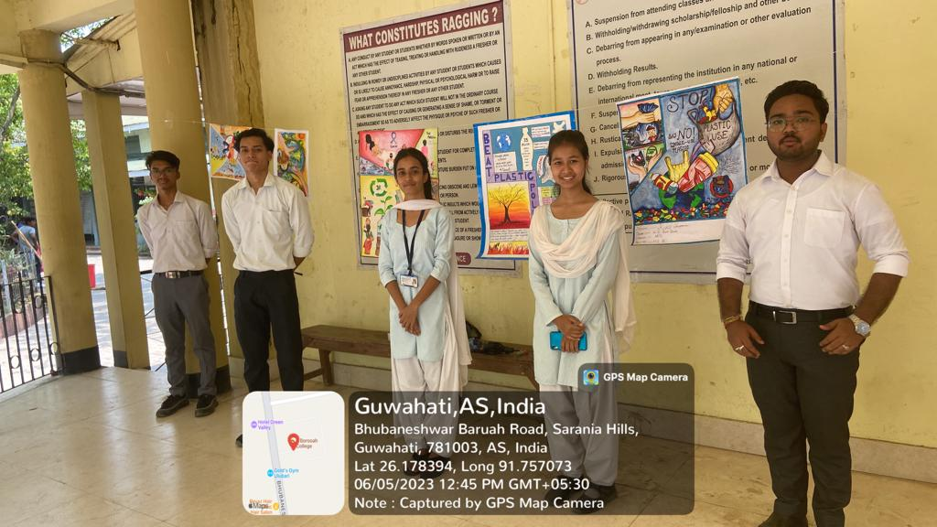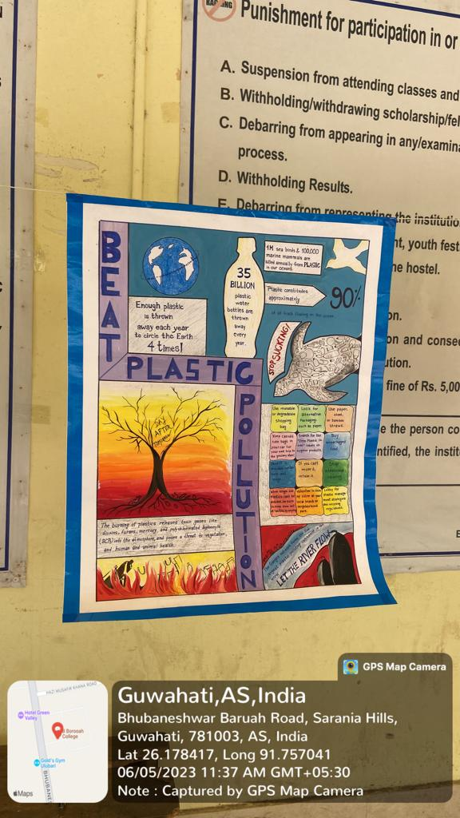
FIRST PRIZE IN POSTER MAKING COMPETITION WINNER DAISYMONI DAS, UG 2ND SEMESTER, DEPARTMENT OF GEOGRAPHY.

