
FLORA OF b. bOROOAH cOLLEGE
GUWAHATI: ASSAM
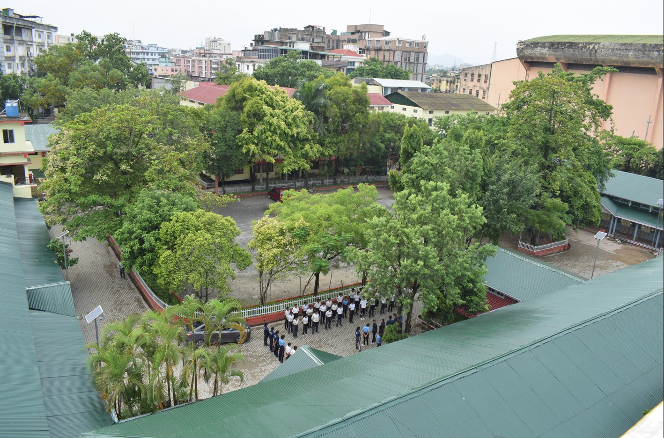
fIRST eDITION: 2022
DEPARTMENT OF BOTANY
B. BOROOAH COLLEGE

INTRODUCTION
Biodiversity may be defined as the totality of different organisms, the genesthey contain, and the ecosystems they form. It is an intregal part of our daily life and livelihood and constitutes the resources upon which families, communities, nations and future generations depend. Human society from the very beginning of its appearance on this earth has been indispensably associated with the plant kingdom for its survival (Elizabeth and Dowdeswell, 1995; Kumar and Singh, 2013). Plants provide our basic food crops, building materials, medicines, oil lubricants, rubber,and latex such as resins, waxes perfumes, dyes and fibers. (Prance, 1997)
Floral diversity under the purview of biodiversity deals with plant species growing in a particular region. The study of floral diversity provides knowledge about various plant species, regarding their nomenclature, distribution, utility and ecology. Such studies also help us to understand the basic aspects of biology. Floral diversity is of utmost value to basic research because the data generated through these studies are highly useful in ecological, taxonomic and evolutionary studies. Due to large scale of anthropogenic disturbances in the form of exclusive agricultural practices, industrialization, live stock feed, fuel wood collection, the floral diversity of our nation is facing threat of extinction.
We as a part of civil society have the moral responsibility to conserve floral biodiversity in our surrounding. Educational institutions are knowledge hub of country, from where we acquire the knowledge and skills to live as responsible human beings.
Maintaining the floral diversity of educational institutions is of utmost importance. Campus flora in an institution is a unique opportunity of learning as an outdoor classroom exercise and how sustainable utilization of plant resources needs to be carried out along with the conservation of rare and endangered species.
Keeping this point of view, the present work has been carried out in the college campus to document the floralbiodiversity of the whole area.

MATERIAL AND METHODS

STUDY AREA
The present study was carried out in the campus of B.Borooah College, Ulubari. It was established in 1943 and islocated in the Guwahati block of Kamrup Metro district of Assam. Total area of the campus isapprox. 72 thousand sq ft. It is geographically located at 26.1⁰ N and longitude 91.7⁰ E.Graduate and postgraduate courses are being offered in various disciplines in this college.The climate of Guwahati is humid and temperate; compared to winter summer receives much more rainfall. Average annual temperature and rainfall is 24⁰C and 3038 mm respectively.
To maintain the biodiversity and greenery of this college, awareness campaigns are held annually and students are encouraged to take part in plantation drives for maintaining a clean and pollution free campus. Small steps are being taken to conservethe biodiversity of the campus by maintaining a botanical garden where most of the plants are economically important along with a orchid house, a mushroom house, and some bonsai plants and a small garden of medicinal plants.
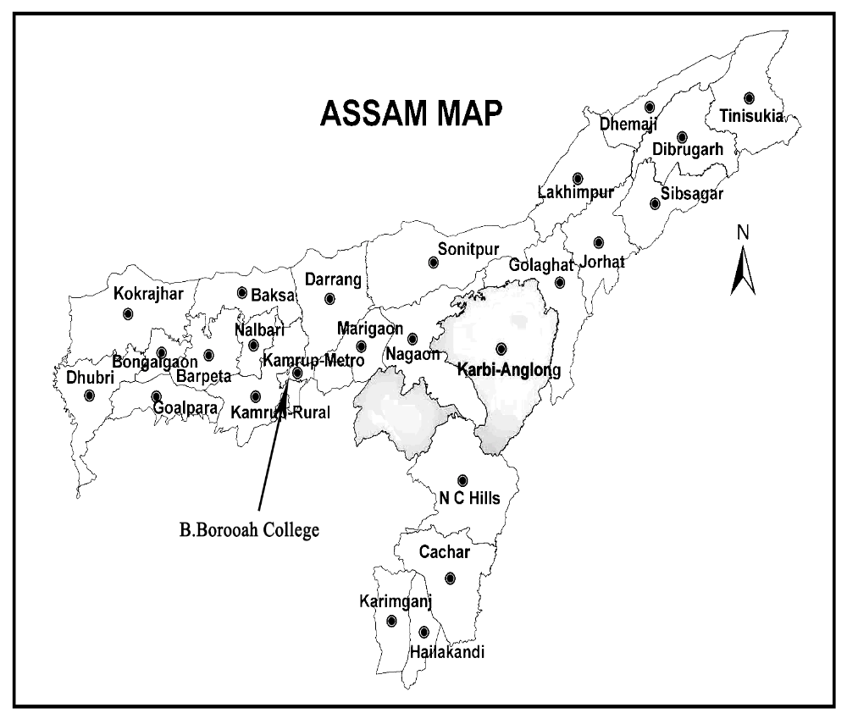
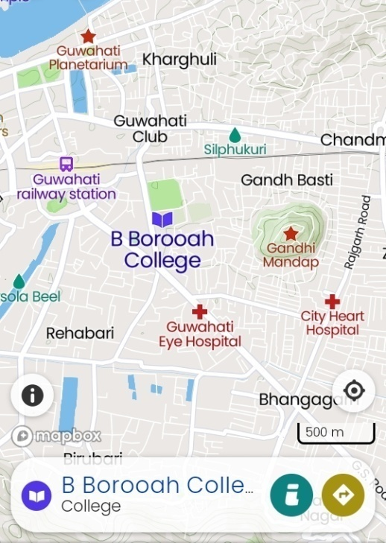
Map of Assam and Study Area B.Borooah College

METHODOLOGY

FIELD SURVEY AND HERBARIUM METHOD

The survey was carried out in the month of Januaryto October, 2021 and was based on the field work which involved collection and documentation of plant species occurring in the entire college campus.The collected specimens were processed into mounted herbarium sheets following standard herbarium techniques (Jain& Rao, 1977).Some of the important characteristics like colour of leaf and stem, branching pattern, habit, habitat, size, etc were noted down in the field during collection.
The collected specimen was identified by comparing the field notes and observations with the descriptions available in authentic literature (Kanjilal et al……………….). The families are arranged according to Bentham and Hooker’s system of classification. The species within the family are arranged alphabetically. For up to datenomenclaturecertain websites such as www.theplantlistorg.andwww.plantoftheworldonline.orgare consulted.Accepted name of the species is written in bold letters followed by synonyms available with original citation. The photographs of the species were taken in natural habitat. Floristic composition of herbs, shrub, trees were recorded. The families are arranged according to Benthamand Hooker’s system of classification.

RESULT AND DISCUSSION

The study was intended to investigate and document the flora of the B. Borooah College, campus. During this survey period a total of 116 plant species belongs to 105 genera and 59 families were observed in the college campus. In the recorded 59 families, 52 families belong to angiosperms,4 from gymnosperm, 3 from pteridophytes. The angiosperm comprises 41 families of dicotyledons with 77 species,11 families of monocotyledon with 31 species and 4 families of gymnosperm with 4 species, 3 families of pteridophytes with 4 species. Asteraceae is the most dominant family followed by Fabaceae, Euphorbiaceae, Moraceae, Arecaceae and Araceae.The campus biodiversity is of moderate level.Here, many ornamental, economically important plants are found. Most of the plants are of medicinal value and few are edible. In terms of preserving floral diversity, some steps have been taken. A botanical garden is maintained in the campus and every year on the occasion of World Environment Day tree plantation in vast numbers in and outside the campus is carried out by the students of the college.

CONCLUSION

Biodiversity conservation is need of the hour and taxonomic knowledge is crucial to meet the challenges of biodiversity conservation in 21st century. It is of fundamental importance for understanding biodiversity & ecosystem functioning as it provides us with data to explore and describe biodiversity through scientific analysis. The present study provides the basic information about the different plant species of B. Borooah College. The natural beauty of B. Borooah College campus, with its native plant diversity and introduction of ornamentals and cultivated plants species with great aesthetic value adds ecological uniqueness and is of is of resource importance. Thus taking a stroll around the campus would enrich the botanical knowledge, ecological consciousness and conservation values not only of the academia but also of the common people. The B.Borooah college campus environment with its diversity of native plant species, cultivated ornamental plants, provides a unique opportunity for learning as an outdoor classroom exercise.

Sl no | Family | Scientific name | Habit | Edible part | Uses
1 | Dilleniaceae | Dilleniaindica L. | Tree | Pulp | The fruit pulp is sour and used in Indian cusine in curries , jam and jellies
2 | Annonaceae | Annonasquamosa L. | Tree | Fruit | Leaves used in dysentery and ulcers. Fruit is edible
3 | Nympheaceae | NymphearubraRoxb. ex Andrews. | Aquatic | Flower,seeds,rhizome | Rhizome are used as cure for dyspepsia
4 | Brassicaceae | Rorippadubia (Pers) H.Hara | Herb | Not edible | Beneficial for treating wounds
5 | Cleomaceae | Cleome viscose L. | Herb | Juice of leaf and seed | Seeds are anthelmintic and carmintic and carminative
6 | Bixaceae | Bixaorellana L. | Shrub or Small tree | Seed | Seed used for soft drink
7 | Carrrophyllaceae | Dianthus chinensis L | Herbs | Whole plant | Used as a bitter tonic herb that stimulates urinary & digestive system
7 | Carrrophyllaceae | Stellaria media ( L | Throughout the year | Whole plant | Leaf is useful for lung diseases
8 | Malvaceae | Hibiscus rosa – sinensis L. | Shrub | Young leaves | Leaves is used hair diseases
8 | Malvaceae | Malvavsicuspenduliflorus | Shrub | Leaves and fruits | Fruit can be used for making jelly or syrup
9 | Oxalidaceae | Oxalis latifoliaKunth. | Herbs | Leaves , flowers &seed pods | Plant is anthehelmintic
10 | Rutaceae | Citrus lemon L. | Shrubs | Leaf , root twing and stem | Lemon used as a soure of juice and treatment of cold and flu
10 | Rutaceae | Murryapaniculata (L.) Jack | Shrubs | Leaf , root, twig | Leaves are stimulant , astringent used for diaarhea and dysentery
11 | Meliaceae | Azadiractaindica A. Juss | Tree | Whole plant. | Leaves is used for leprosy and eye disorder
12 | Anacardiaceae | Mangiferaindica L. | Tree | Mesocarp | Mango is source of vitamin , it help improves eye sight
13 | Moringaceae | Moringaoleifera Lam. | Tree | Flower , leaves & fruit | Moringaleves used in many dishes . Flower is helpful in reduceing the blood pressure
14 | Fabaceae | Acacia pycnanthaBenth. | Tree | Pods | Herbal medicine for diarrhea
14 | Fabaceae | Bauhinia variegata L. | Tree | Leaves,flower bad, young buds | Flower is used in dysenorrhoea ,it is also antifungal and antimicrobial
14 | Fabaceae | Delonixregia(Hook.) Raf. | Tree | Leaves | Used in treatment of infectious hepatitis
14 | Fabaceae | Dalbergiasisso DC. | Tree | Leaves | Used as fire wood timber , bark paste anthelminthic
14 | Fabaceae | Samneasaman (Jacq.)Merr. | Tree | Seed, pods | The pod can be eaten , pulp can be made into drink
15 | Rosaceae | Rosa indica L. | Shrub | Petals | Used as ornamental
16 | Crassulaceae | Kalanchoepinnata (Lam.)Pers. | Succulent | Leaves | Juice of leaves useful in kidney stone
17 | Combretaceae | Terminaliaarjuna (Roxb.)Wight &Arn. | Tree | Bark | Bark reduce the blood pressure
17 | Combretaceae | TerminaliachebulaRetz. | .Tree | Bark | Used in dysentery
18 | Myrtaceae | Psidiumguavaja L. | Tree | Fruit , Leaves | Leaves used in treatment of stomach pain & diabetes
18 | Myrtaceae | Callistemon citrinus (Curtis) Skeels | Tree | Not known | Used as ornamental
18 | Myrtaceae | Syzgiumcumini (L.)Skeels | Trees | Fruit | Fruit is natural blood purifier
19 | Lythraceae | LawsoniainermisL. | Shrub | Leaves | Used as as dye
20 | Begoniaceae | Begonia cucullataWilld. | Herb | Whole plant | Juice of the plant is drunk to relieve the headache
21 | Cactaceae | Opuntiaficusindica (L.) Mill | Succulent | Fleshy part of fruit | Traditonal folk medicines for diabetes
22 | Araliaceae | Polysciasfruticosa(L.) Harms. | Shrub | Roots | Roots are used as diuretic
22 | Araliaceae | Polysciasscutellaria(Burm.F.) Fosberg | Tree | Leaves ,Root | Leaves and root used as an antiseptic & deodorant
23 | Rubiaceae | Neolamarckiacadamba (Roxb.)Bosser. | Tree | Fruit , stem,stemstalk,bracts&floweres | Bark is used to wash the infected wound
23 | Rubiaceae | MussaendaerythrophyllaSchumach&Thonn. | Shrub | Leaf | Leaf used in the treatment of leprosy and jaundice
23 | Rubiaceae | Ixoracoccinea L. | Shrub | Young shoot | Decoction of the root is used as a sedative
24 | Compositaeasteraceae | Sonchusoleraceus (L.) L. | Herb | Leaves | Juice of the plant used in cleaning and healing ulcers
24 | Compositaeasteraceae | Partheniumhysterophorus L. | Herb | Leaves stalk | Used in diaarhea and dysentry
24 | Compositaeasteraceae | Ecliptaprostrate(L.)L. | Herb | Tender , leaves, young shoot | Used in treatment of infectious hepatitis
24 | Compositaeasteraceae | Calyptocarpusvialis Less. | Herb | Not known | Pulp of the fruit has laxative property
24 | Compositaeasteraceae | Enhydrafluctuans DC. | Herb | Leaves | Young part used as a salad
24 | Compositaeasteraceae | Crassocephalumcrepidiodes (Benth.) S.Moore | Herb | Leaves, stems | Mucilaginous leaves and stems are eaten as vegetable
24 | Compositaeasteraceae | Youngia japonica (L.)DC. | Herb | Younger leaves | Younger leaves used in salad
24 | Compositaeasteraceae | Mikania micrantha | Herbaceous vine | Not known | Leaves are used for treating stomachache
24 | Compositaeasteraceae | Cyanthillium cinereum(L.)H.Rob | Herb | Leaves | Seeds are anthelmintic and carminative
24 | Compositaeasteraceae | Ageratumconyzoides(L.)L. | Herb | Notedble | Used to treat wound
25 | Saptoceae | Mimusop selengi L. | Tree | Fruit,root, flowert | Roots used as a diruretic
26 | Oleaceae | Nyctantnes arbour – tirstis | Shrub | Flower, Leaves | Bark has antimicrobial property
27 | Apocynaceae | Tabernaemontanapandacaqui Lam. | Shrub | Root | Root is used to treat the fever
27 | Apocynaceae | Catharanthus roseus (L.) G. Don | Herb | Root | Used in treatment of high blood pressure
27 | Apocynaceae | Pulmeria alba L. | Tree | Bark | Bark is used in treatment of diaarhoea and gonorrohea
28 | Convolvulaceae | Ipomea carica (L.)Sweet. | Climber | Leaf and root | It is highly potent against malaria
29 | Solanaceae | Solanum nigrum L. | Herb | Root | Juice of the root is used against asthma.
29 | Solanaceae | Capsicum annum L. | Herb | Fruit | Mix of red chillies medicated with castor or oil is useful in easing from pain
30 | Scrophulariaceae | Scorpiadulcis L. | Herb | Whole plant | It used in diabetes
31 | Lentibulariaceae | Utricularia gibba L | Aquatic | Not known | It is folk remediesare mild astringent & diuretic
32 | Verbenaceae | Duranta erecta L. | Shrub | Not edible | The plant is used as an insect repellent
33 | Lamiaceae | Leucas aspera | Shrub | Leaves and stem | It is a herb that reduce fever
33 | Lamiaceae | Ocimum tenuiflorum L. | Shrub | Leaves | Leaves used in treatment of cough
34 | Nyctaginaceae | Bougainvilleaspectabillis Willd. | Shrub | Flower bracts | Traditionally used in hepatitis
35 | Amaranthaceae | AmaranthusvirdisL. | Herb | Whole plant | Used in treatment of fever ,cough
36 | Chenopodiaceae | Chenopodium album L. | Herb | Whole plant | The leaves and young shoots of the plant used in disches such as soups , curries , paratha
37 | Piperaceae | Peperomia serpens (Sw.)Loudan | Epiphyte | Whole plant | Plant antioxidant antibacterial & anti- inflammatory properties that helps to solve many health issues
38 | Lauraceae | Cinnamomum tamala (Buch ham) Th.G.G.Nees | Tree | Leaves | Leaves used as spice , also strong effects gastrointestinal system
39 | Proteaceae | GrevelliarobustaA.Cunn.ex R.Br. | Tree | Not known | Yellow & green dye from the leaves used for dying
40 | Euphorbiaceae | Riccinus communis | Shrub | Seed | Members of bodo tribes use the leaves of the plant to feed the larvae of muga and silkworms
40 | Euphorbiaceae | Codiaum variegatum (L.)Rumph. ex A. Juss | Shrub | No edible part | The leaf of the plant edible and used as spice.
40 | Euphorbiaceae | Acalypha indica L. | Herb | Leaf juice | Herb used to eliminate intestinal properties
40 | Euphorbiaceae | Euphorbia hirta L. | Herb | Tangy flower | Used in breathing disorders
40 | Euphorbiaceae | Euphobi amili des moul | Shrub | Not known | It widely used for treatment of warts
40 | Euphorbiaceae | Euphorbia nerifolia L. | Shrub | Fresh leaves | Fresh diluted latex is used as purgative
41 | Moraceae | Morus alba L. | Tree | Fruit | Leaves of morus used to feed silkworms
41 | Moraceae | Ficus benghalensis L. | Tree | Fruit but is eaten | Leaves and twigs are fooder for cattle
41 | Moraceae | Ficus elastic Roxb. | Tree | Not edible part. | Latex is used in making of tier
41 | Moraceae | Ficus retusa L. | Tree | Leaf juice& bark. | Roots and leaves paste applied to wounds
41 | Moraceae | FicussemicordataBuch.-Ham. ex Sm. | Tree | Fruits | Bark,leavesued in treatment of ulcers
41 | Moraceae | Artocarous heterophyllus Lam. | Tree | Fleshy pod and seed eaten | Ashes of the leaves are used for treating ulcers , diarrhea , boils , stomach – ache and boils

MONOCOTS
1 | Hydrocharitaceae | Hydrilla verticilliata (L.f.)Royle | Aquatic | Whole plant | Plant nutritious,improvediagestion
2 | Orchidaceae | Paphiopedilum farrieanum Lindley.)Stein | Terrestrial | Not known | It is ornamental plant with high deman.
2 | Orchidaceae | Colegyne viscose Rchb.f. | Epiphtes | Not known | Ornamental plant
2 | Orchidaceae | Cymbidium aloeifolium (L.)Sw. | Epiphyte | Leaves | Used fever and chronic illness
2 | Orchidaceae | Eria paniculata Lindl. | Epiphyte | Not known | Ornamental plant with high demand
2 | Orchidaceae | Pholidata imbricata Hook. | Epiphyte | Roots | Useful in stomach disorders
2 | Orchidaceae | Aerides multifloraRoxb. | Epiphyte | Not known | Ornamental plant
2 | Orchidaceae | Aerides odorata Lour. | Epipyhte | Leaves | Used in treatment of pneumonia and paralysis
2 | Orchidaceae | Dendrobium aphyllum (Roxb.)C.E.C.Fisch. | Epiphyte | Root | Used in variety of disorder such as nourishing the stomach
2 | Orchidaceae | Dendrobium nobile Lindl. | Epiphyte | Whole plant | The plant is a source of tonic ,astrigent
2 | Orchidaceae | Dendrobium jenkinsii Wallich ex Lindley | Epiphyte | Not known | Used as ornamental
2 | Orchidaceae | Dendrobium moschatum (Buch.-Ham)Sw. | Epiphyte | Root | Lower the blood pressure
3 | Musaceae | Musa paradisiaca L. | Herb | Fruit , Pseudostem | Fruit helps to maintain cardiovascular & protection
4 | Heliconiaceae | Heliconia psittacorum L. | Herbs | Underground rhizome | Used in intestinal pain & jaundice
4 | Liliaceae | Aloe vera(L.)Burm.f. | Succulent herb | Leaf | Heals burns ,Improves diagestive health
4 | Liliaceae | Chlorophytum comosum(Thunb.)Jacques. | Perennial herb | Leaves ,stem ,root | Usedin treatment of bronchities
4 | Liliaceae | Dracaena reflexa Lam. | Shrub | Not known | Cure malaria , dysentery &diaarhoea
5 | Pontederiaceae | Eichhornia crassipes(Mart.)Solms. | Aquatic | Young leaves and Stalk | Stem used as a braiding material & a source of fiber
6 | Commelinaceae | Tradescantia spathaceaSw. | Herbs | No edible part | It is used in nasal bleeding
8 | Arecaceae | Cocos nucifera L. | Tree | Endosperm | Coconut is taken by mouth for bladder stones , diabetes
8 | Arecaceae | Dypsis b. lutescens (H.Wendl.)Beentje& J. Dransf. | Tree | Berries | It is absorbs the harmful gases , used as ornamental
8 | Arecaceae | Roystonea regia (Kunth)O.F. Cook . | Tree | Terminal bud | Seed is used as source of oil
8 | Arecaceae | Areca catechu L. | Tree | Nut | Areca is used for treatment of a mental disorder called schizophrenia
9 | Araceae | Syngonium podophyllum Schott. | Climber | Leaves | Root and bark antibacterial & inflammatory
9 | Araceae | Monstera deliciosaLiebm. | Epiphyte | Fruit | Fruit is very rich in vitamin c, boost the activity of immune system
9 | Araceae | Philodendron bipinnatifidum Schott ex Endl. | Epiphyte | Fruit and Seed | Roots are used as a drastic
9 | Araceae | Diffenbachia seguine (Jacq.)Schott. | Herb | Not edible | The sap used against the snake bite
9 | Araceae | Spathiphyllum wallisiiRegel . | Herb | Not edible | Used as ornamental,it also have a air purifying properties
10 | Poaceae | Thysanolaena latifolia (Roxb. ex Hornem.)Honda. | Herb |  | Young leaves are used in making brooms
10 | Poaceae | Cyanodon dactylon (L.)Pers. | Herb |  | Traditionally it used as a laxative ,coolant , expectorant ,carminative and as a brain and heart tonic
10 | Poaceae | Bambusa vulgarisSchrad. | Herbs |  | For construction of house . Making of paper

GYMNOSPERMS
1 | Pinaceae |  | Cedrusdeodhara (Lamb.)G. DON |  | Tree |  |  | Wood also good for constructing bridges` and furniture
2 | Cupressaceae |  | Thuj aoccidentalis L. |  | Small sized tree |  |  | Leaves and leaf oil used as a meidicine
3 | Cycadaceae |  | Cycas revolutaThunb. |  | Tree |  |  | seeds used for high blood pressure
4 | Zamiaceae |  | Zamia furfuracea L. f. |  |  |  |  | It is used for the production of sago starch
PTERIDOPHYTES
1 |  | Selaginellaceae |  | Sellaginella semicordata (Wall.ex Hook &Grev.)Spring |  | Fern | Plant decoction is used in treatment of traumatic bleeding, gastrointestinal bleeding.
2 |  | Pteridaceae |  | Pterisvittata L. |  | Fern | It is used in development of health products for ageing and chronic diseases
 |  |  |  | Adiantum capillus – veneris L. |  | Fern | Fronds are used as a greenish or sweet dishes

Description of the plants found in the college campus:

Family: Dilleniaceae
Botanical name: Dillenia indica L.
Synonyms: D. Ellptica Thunb., D. elongate Miq., D. speciosa Thunb.
Common English name: Elephant apple
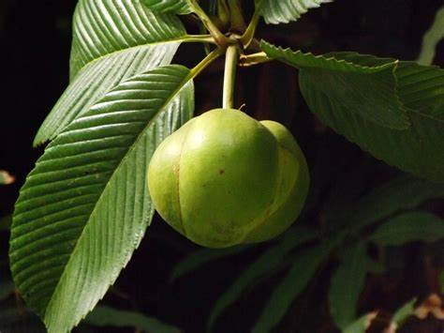
Local name: Outenga (Ass.), Chalta (Beng., Hindi), Pumplung (Karbi); Karambel (Marathi).
Description of plants: Evergreen large shrub, grow up to 15 m tall; leaves 15-36 cm long with a conspicuously corrugated surface with veins; flower large, 15-20 cm in diameter with five white petals and numerous yellow stamens; characteristic round fruits are large, greenish yellow, edible, 5 -12 cm in diameter, aggregate of 15 carpels, each carpel containing five seeds embedded in an edible but fibrous pulp.
Flowering time: January – August; Fruiting time: December – April.
Part used: Spurious fruit.
Medicinal uses: Ripe fruit is taken orally to increase appetite, as laxative, and as medication for abdominal pain.
Other uses: The fruit pulp is sour and used in Indian cusine especially in traditional Assamese recipes and in making pickles and jams.

Family: Annonaceae
Botanical name: Annona squamosa Linn,
Synonyms: A. asiatica L., A. cinerea Dunal, A. forskahlii DC.
Common English name: Custard apple
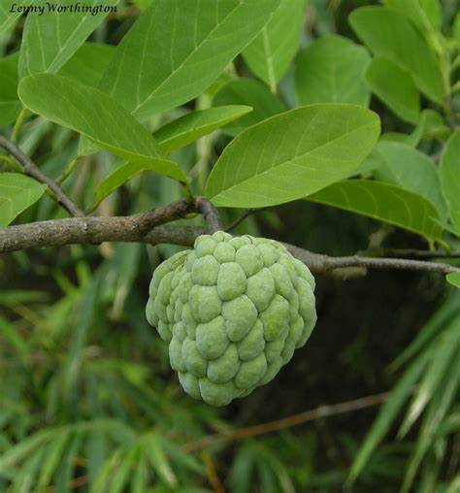
Local name: Atlas (Ass.), Ata (Beng.), Sita phal (Hindi).
Description of plants:A moderate sized erect deciduous tree with a round or spreading crown; the ill-smelling leaves are deciduous, alternate, oblong or narrow-lanceolate; flowers complete, bisexual in drooping clusters, fragrant, slender, with 3 outer fleshy, narrow petals, light-green externally and pale-yellow with a dark-red or purple spot on the inner side at the base; the compound fruit may be symmetrically heart-shaped, or irregular; or nearly round, or oblate, with a deep or shallow depression at the base.
Fruit is fleshy with a rough surface and consists of 20-40 seeds.
Flowering time: March-May; Fruiting time: August-January.
Part used: Fruit and leaves.
Medicinal uses: Leaf juice is used to treat dysentery and ulcers.
Other uses: Fruits are edible.

Botanical name: Monoon longifolium (Sonn.) B. Xue & R. M. K. Saunders
Synonyms:Uvaria longifolia, Polyalthia longifolia(Sonn.)Thwaites
Common English name: Indian mast tree
Local name: Debdaru (Ass., Beng.),
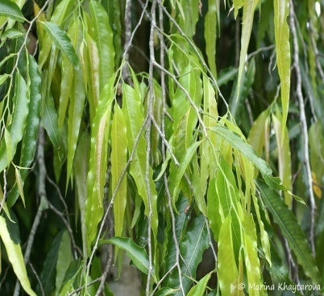
Description of plants: Trees to 20 m tall; trunk straight; branches finely striate, minutely puberulent when young, glabrous when mature. Petiole 5-10 mm; leaf blade ovate-oblong to ovate-lanceolate, stiffly membranous to thinly leathery, glabrous, abaxially pale, adaxially dark glossy green, secondary veins 18-24 on each side of midvein, reticulate veins raised on both surfaces, base cuneate, obtuse, or rounded, margin undulate, apex acuminate. Inflorescences axillary, fasciculate and shortly pedunculate, racemose, or umbelliform and sessile, mostly many flowered; peduncle to rachis to 1 cm. Pedicel 2-4 cm; bracteole usually 1, at middle of petiole, to 1 mm, tomentose. Sepals ovate-triangular, outside tomentulose, inside glabrous.Petals greenish yellow, narrowly triangular-lanceolate, subequal, spreading, inside puberulent except basally, base broad, apex acute.Stamens 8-10 cm; connectives apically convex. Carpels 20-25, ca. 1.5 mm, apex tomentulose; ovule 1 per carpel; stigmas sessile, rectangular to oblong, pubescent, with a groove on inner side and continuing down inner side of ovary. Monocarp stipes 1-2 cm; monocarps 4-8, purple, ovoid, glabrous.
Flowering time: March -April; Fruiting time: May-June
Part used: Leaves and bark.
Medicinal uses: Bark is used as febrifuge, leaf juice is used to treat fever, inflammation and diabetes
Other uses: Ornamental and Timber yielding plant.

Family: Nympheaceae
Botanical name: Nymphaea rubra Roxb ex Salisb.
Synonyms: N. lotus L.
Common English name: Water lily
Local name: Bhet phul (Ass.), Nilkamal(Hindi), Sapla(Beng.),
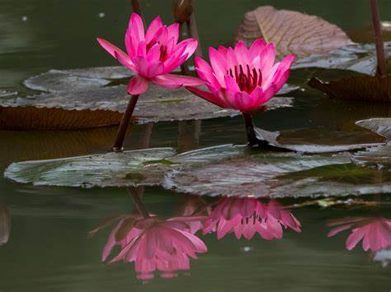
Description of plants:.Aquatic perennial herbs; stem maroon coloured, laticiferous. Rhizomes short, ovoid, stoloniferous. Leaves suborbicular, peltate to broadly ovate, base deeply hastate, apex obtuse to retuse, lowest pair of veins straight and divergently produced and basal lobes, basal lobes slightly unequal, usually floating or submerged, membranous when young, dark red when young, reddish maroon, later olive green glabrous when mature on both sides, densely pubescent, prominently veined when mature beneath, submerged leaves smaller, cordate or sagittate, long petiolate. Flowers bisexual, usually solitary and floating, crimson red or dark red, with long peduncles, receptacle cylindrical, sepals 4, free, oblong-lanceolate, brownish green outside, petals about 10-25, oblong-lanceolate, base attenuate, apex subacute, white. Stamens numerous, filaments of the inner stamens with purplish band outside, lanceolate, longer than anthers, anthers partially sunken, carpels completely united, ovary superior , stigma flat with a hemispheric central projection, red and stigma receptive only during the first day stigmatic appendages oblong. Fruit berry globose.
Flowering time: August; Fruiting time:January
Part used: Rhizome
Medicinal uses:Rhizome are used as cure for dyspepsia
Other uses:Stem and fruits are used as vegetables.

Family: Cruciferae (Brassicaceae)
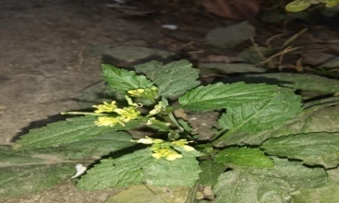
Botanical name: Rorripa dubia (Pers.) H. Hara
Synonyms: R. indica var. apetala (DC.) Hochr.,
R. sublyrata (Miq) H. Hara.
Common English name: Yellow cress.
Local name: Ban Sariyah(Ass.)
Description of plants:.Annual or biennial herb, usallyhairless, 10-15 cm tall.Stem erect. Leaves simple much branches from the base and above.Flower are borne in racemes , many flowered, about 6-10 cm long. Also flower are bisexcual , yellow , flower stalk erect, sepals 4 , erect , liniear , oblong,petals mostly absent or 4, stamen 6. Fruit is siliqua, spilliting, liniear cylindrical.
Flowering time: November - April;Fruiting time: Feb-July
Part used: Entire plant
Medicinal uses:Plant juice is beneficial for treating wounds
Other uses:Whole plant is edible.

Family- Cleomaceae
Botanical name: Cleome rutidosperma DC.
Synonyms:CleomeciliataSchult.& Thonn.,Cleome guineensis Hook.f.
Common English name: Fringed spider flower.
Local name: Hurhuriya(Ass.)
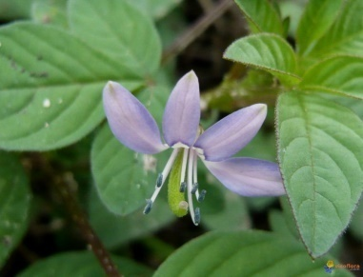
Description of plants:Annualherb, slender, much branched. Young stem filiform. Leaves alternate, leaflet sessile, mostly filiform, narrowly linear. Flowers 3.5mm across , in lax 2-5 flowered terminal and not clearly demarcated racemes ,often solitary , axillary ,pedicels 6 mm long. Petals 4, free yellow with purpul nerves. Stamens 12-18, anthers linear. Ovary superior,bicarpellary,oblong-cylindric, style long, stigma capitate. Fruit capsule.
Flowering time: Dec-April ; Fruiting time:Jan-May
Part used: Whole plant
Medicinal uses:Seeds are anthelmintic and carminative.
Other uses:Young leaves are eaten as vegetable.

Family: Bixaceae
Botanical name: Bixa orellana L.
Synonyms: B. acuminata Boj. , B. americana Poir
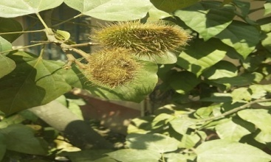
Common English name: Lipstick plant
Local name: Sendur gos (Ass.), Latkan (Hindi)
Description of plants:.Shrub or small tree. Leaves ovate acuminate, base cordate, glossy , glabrous, lateral nerves 4-5 pairs , petioles 4-7 cm , stipules present. Flowers 3-5 cm across , in terminal corymbose panicales , pinkish white ; sepals 5 ovate, purple , scaly , petals 5 . Fruit globular,ovoid capsule . Seed fleshy ,covered with red- orange pulp.
Flowering time: June -Dec ; Fruiting time:Jan -Feb
Part used: Seeds.
Medicinal uses:Infusion of leaves is effective against bronchitis, sore throat and eye inflammation.
Other uses:Seeds used for soft drink & febrifuge.
Family- Caryophyllaceae
Botanical name: Dianthus chinensis L.
Synonyms: D. fischeri Spreng. , D. seguieri Vill, D. umbellatus DC
Common English name: ChinaPink
Local name: Dianthus
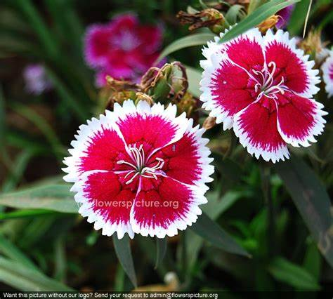
Description of plants:Perennial herb, stem erect or ascending, dichotomously branched. Leaves simple, opposite, clustered near at the base.Flower bisexcual, bracts 4, paired,ovate, petals 5,free,white, dark pink. Stamens usually 10, filament distinct, anther 2 locular.Ovary superior , uilocular , staminodes absent, gynophores long , styles 3 , filiform, Stigma 2. Fruit capsule is surrounded by petals.
Flowering time:Jan-Feb ; Fruiting time:March
Part used: Whole plant
Medicinal uses:Plant juice is used to treat wounds.
Other uses:As zest to ice-cream, fruit salad.

Botanical name: Stellaria media (L.) Vill.
Synonyms: S. media var media,S. media var. normalis Speg. , S. monogyna D. Don
Common English name: Chickweed
Local name: Morolia (Ass., Bodo), Buch-bucha(Beng.)
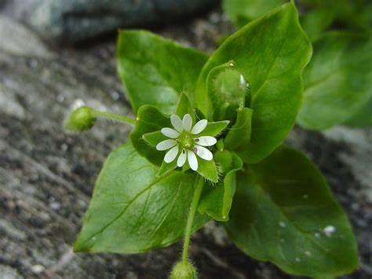
Description of plants:.Annual herbs, caespitose or tufted.Stem decumbent or ascending, diffusely branched from the base, slightly quadrangular or terete, glabrous or pubescent with line of hairs, rooting at nodes, rootstock slender. Leaves simple, opposite, lanceolate-ovate to elliptic,, base cuneate to rounded, margin entire or ciliate, apex acute or shallow acuminate, obscurely 3-5 veined, impressed above and slightly prominent beneath, glabrous above and slightly pubescent beneath, bright green, petiole becoming shorter towards the shoot, stipules absent. Inflorescence usually dichasial cymes of few to many flowered terminal leafy cymes. Flowers bisexual, hypogynous or weaky perigynous, pedicel erect, glabrous or pubescent, bracts paired, foliaceous, lanceolate-ovate, margins scarious, apex acute to shallow acuminate, sepals 5, lanceolate-ovate, with obscure midrib, herbaceous, persistent, glandular hairy outside, petals 5, oblanceolate to obovate, white, usually shorter than sepals, creamish, limb bi-fid from the base, margins entire, apex emarginated, sometimes absent. Stamens 3-5, filaments distinct, anther reddish brown or reddish violet, curled when mature. Ovary superior, unilocular rarely trilocular, ovules many, style 3, glabrous, stigma 3.Fruit capsule.
Flowering time: March-April; Fruiting time:April-May
Part used: Whole plant.
Medicinal uses:Plant juice is used to treat itchy shin disorder and bronchitis.
Other uses:Whole plant is edible.

Family -Malvaceae
Botanical name: Hibiscus rosa sinensis L.
Synonyms: H. fesatalis Salisb. ,H. rosa sinensis var rosa sinensis
Common English name: China rose
Local name: Joba (Ass.), Rokto joba(Beng.), Gurhal (Hindi)
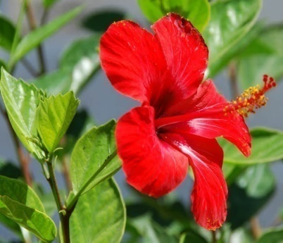
Description of plants:.Perennial shrub, taproot system .Stem cylidical woody . Leaves alternate , simple , reticulate veneation. Inflorescence solitary cyme.Flower bisexcual , large , pentamerous, hypogynous , bracteoles outer to the calyx, Sepals 5 , valvate aestivation , corolla , petals 5 , variously coloured ; numerous stamen , monadelphous ,anther monothecous .Ovarysuperior,pentacarpillary and synocarpous, style simple , long , stigma 5 . Fruit capsule, globose.
Flowering time:Jan-March; Fruiting time:March-May
Part used: Leaves and flowers.
Medicinal uses:Flowers and leaves are used to treat gall bladder attacks, high blood pressure, dry coughs and skin diseases.
Other uses:Ornamental, Used to make tea preparations.

Botanical name: Malvaviscus penduliflorous DC.
Synonyms: M. arboreus var longifolius Schery ,M. arboreus subsp. penduliflorus (DC.) Hadac
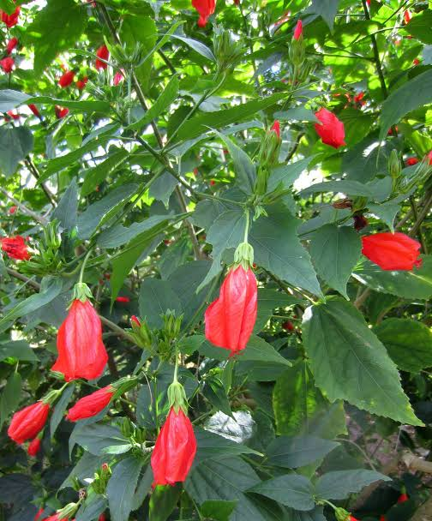
Common English name: Pendulous sleeping hibiscus
Local name: Tikoni joba(Ass.),Lanka joba(Beng.)
Description of plants:Shrubs, up to 2 m tall, branchlets are hairy to hairless. Leaves lanceshaped to narrowly ovate .Flowers occur singly, hanging from the leaf axils, on 1.4 cm long stalks; red in colour, tubular false sepals about 8, spoonshape, sepalsare slightly larger than epicalyx, corolla showy. Staminalcoloumn is 5-7cm long. Ovary superior , 10 locular axile placentation. Fruit berry.
Flowering time: Throughout the year ; Fruiting time:Throughout the year
Part used: Leaves, flower and fruit
Medicinal uses:Flowers and leaves are used to treat gall bladder attacks, high blood pressure, fever and cough.
Other uses:Fruit can be used for making jelly or syrup. Flower is edible raw, leaves are also edible when cooked.

Family-Oxalidaceae
Botanical name: Oxalis latifolia Kunth.
Synonyms: O.vespertilionis Zucc. , Sassia latifolia (Kunth)Holub
Common English name: Wood sorrel
Local name: Tengesi tenga (Ass.), Amrul sak (Beng.), Amboti (Hindi)
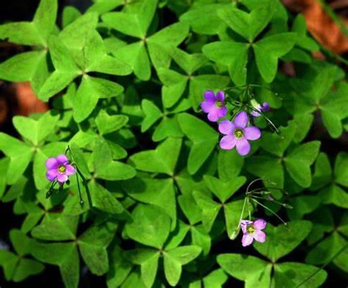
Description of plants:.Erect bulbous herbs, to 25 cm high; stem short or absent. Leaves few, erect; leaflets obconical, base acute, apex retuse. Flowers few, violet, pedicellate, 3-5 together in long-peduncled umbels; sepals green, oblong; corrola composed of 5 petals , violet with yellowish base; stamens 10; filaments alternatively long and short.Fruit rarely developed,it is dehiscent capsule
Flowering time: Aug-Dec ; Fruiting time:Jan-April
Part used: Whole plant
Medicinal uses:Whole plant is anthehelmintic
Other uses:Leaves are eaten as vegetables.

Family -Rutaceae
Botanical name: Citrus limon(L.) Osbeck.
Synonyms: C. meyeri Yu. Tanaka, C. vulgaris Ferrarius ex Mill
Common English name: Lemon
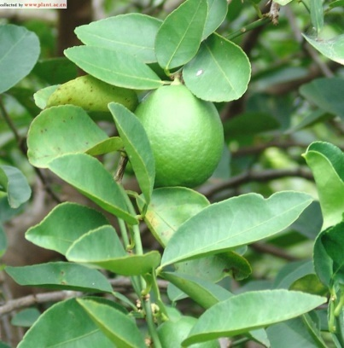
Local name: Nemu tenga(Ass.), Lebu (Beng.), Nimbu (Hindi)
Description of plantsSpinous shrub or tree, 3-6 m tall; branchlets glabrous; bark green. Leaves unifoliolately compound, alternate, ovate or elliptic-oblong.Inflorescences axillary condensed racemes, 5-7-flowered; Flowers shortly pedicellate, usually bisexual or staminate, 5-merous, purplish in buds; calyx urceolate; sepals suborbicular, minute, glabrous; petals purplish tinged abaxially, greenish-white adaxially, ovate-oblong, aestivation imbricate or quincuncial; stamens 30-40; filaments monadelphous or irregularly polyadelphous at base, free above, glabrous or pubescent; anthers greenish-yellow, oblong, apiculate; disk annular ; ovary greenish, subcylindric; style long, thick, stigma globose. Fruits Capsule
Flowering time:Jan-March; Fruiting time:March-July
Part used: Fruit
Medicinal uses:Lemon used as a soure of juice and treatment of cold and flu
Other uses:Used as zest and pulp is used to make juices.

Botanical name: Murrya paniculata (L.) Jacq.
Synonyms: M. paniculatavar. exotica (L.) cc.Huang ,M. paniculata var. omphoalocorpa (Hayata)Tanaka
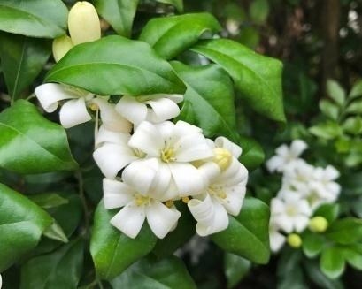
Common English name: Curry leaves
Local name: Narasingha (Ass.), Kari patta(Beng. ,Hindi)
Description of plants:.Small tree or shrub; pinnate leaves ovate to elliptic, leaflet are glossy green and glabrous , wide petiole . Flowers are fragnant and arranged in groups , sepals small glandular , 5 cream coloured petals , stamen 10 , free , disk present . Ovary 2 celled , style fall soon . Fruit Bery red when ripe , round or ovoid .
Flowering time: June-Aug; Fruiting time: Sept-Oct
Part used: Leaves
Medicinal uses: Leaves are stimulant, astringent used for diaarhea and dysentery.
Other uses: Leaves are used as flavouring agent in currys.

Family: Meliaceae
Botanical name: Azadiracta indica A.Juss.
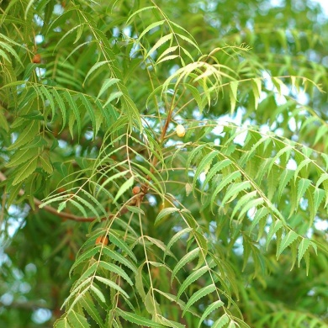
Synonyms: Melia azadirachta L., Meliaindica (A.Juss)Brandis
Common English name: Indian lilac tree
Local name: Maha neem (Ass.), Neem (Hindi, Beng.)
Description of plants:.Medium sized evergreen tree , reaching up to 15 to 30 m in height . Neem has deep tap root . Bark is grey . Leaves alternate , petioled ,clustered at the end of branches unequally pinnate . Leaf let are 5-10 cm long 1.2 – 4 cm broad . Flowers are numerous, white borne in clustered, bisexcual,actinomorphic,pentamerous, calyx lobes imbricate, petalsfree. Fruit is drupe
Flowering time: April ; Fruiting time:June
Part used: Leaves, Fruit, Bark
Medicinal uses:Leaves is used for leprosy and eye disorder, bark is used as astringent.
Other uses:Fruit oil is used as insect reppelant.

Family- Anacardiaceae
Botanical name: Mangifera indica L.
Synonyms: M. austroyunnanensis H.
Common English name: Mango
Local name: Aam(Ass., Beng.,Hindi)
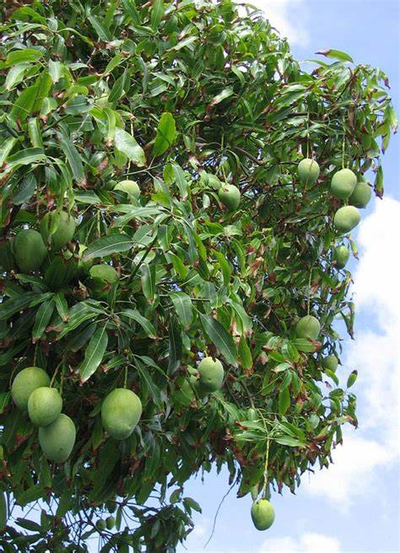
Description of plants:Evergreen trees, to 30 m high, bark dark grey, rough . Leaves simple, alternate, clustered at the tips of branchlets ; lamina elliptic, elliptic-lanceolate, linear-oblong, base attenuate or acute, apex acuminate , margin entire, glabrous, shiny, coriaceous. Flowers polygamous, yellowish-green, in terminal panicles; pedicels jointed; bract deciduous; calyx 4-5 , ovate, imbricate, hairy without, cauducous; petals 4-5, oblong-obovate, subequal ; stamens 4-5, inserted inside or on the disc, fertile stamens 1 or 2; filaments free, glabrous; staminodes gland-tipped; ovary sessile, superior, oblique, 1-celled, ovule pendulous; style lateral; stigma simple. Fruit a drupe, oblong-reniform, yellowish-red, mesocarp fleshy, endocarp fibrous
Flowering time: Feb-March ; Fruiting time:April-June
Part used: Leaves and Fruit
Medicinal uses:Leaf extract is used to treat diabetes and inflammation.Mango is a source of vitamin, it help improves eye sight and digestion.
Other uses:Raw mango juiceisprepared which is extremely nutritious.

Family-Moringaceae
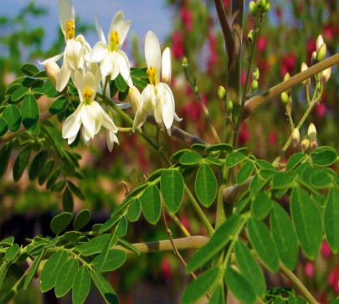
Botanical name: Moringa oleifera Lam.
Synonyms: Guliandina moringa L.,Hyperanthera moringa (L.) Vahi
Common English name: Drumstick
Local name: Sojina (Ass.), Shajna (Beng.), Sahjan (Hindi)
Description of plants:.A middle sized soft tree with thick corky bark. Leaves compound, with pale green leaflets when young, become darker when older and yellow at the fall period. Flowers small, whitish , honey scented. Fruit is a capsule about 9 - 20 inch. long
Flowering time: Feb-March;
Fruiting time:March-April
Part used: Leaves , Fruit
Medicinal uses:Moringa leaves are used in many dishes. Flower is helpful in reduceing the blood pressure.
Other uses:Fruit is cooked and eaten as vegetable.

Family-Fabaceae
Botanical name: Acacia pycnantha Benth.
Synonyms: A. pycnantha var. petiolaris H. Vilm ,A. westoni Maiden
Common English name: Australian acacia
Local name: Akasia (Ass.)
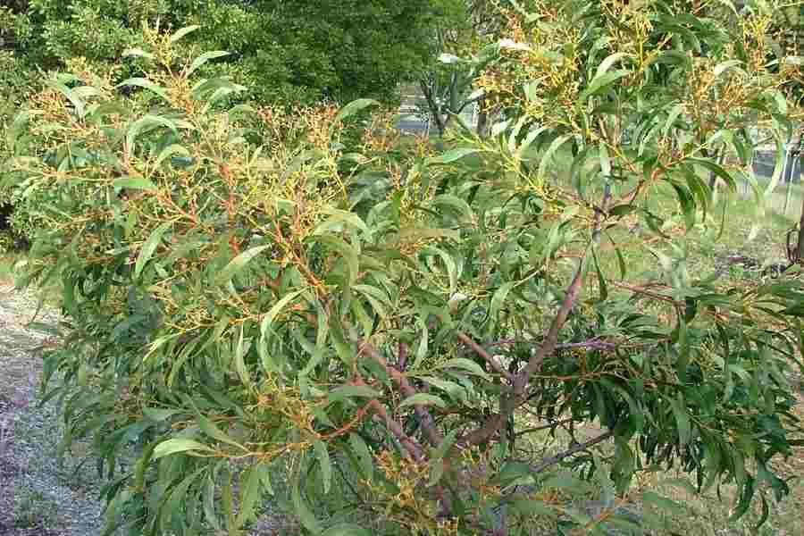
Description of plants:Smalltree, 3-8 m, barks dark brown to grey, smooth in younger plant. Leaves are actually flattened and widened leaf stalks, (petiole), modified leaf stalks called phyllode,but serve as function of regular leaf , when young bear twice compound leaves at the tips . Flowers small yellow or golden fluff in appearance, numerous stamen , 5 relatively inconsipious petals and sepals are closely arranged into a globular clusters . Fruit narrow, elongated pod, hairless.
Flowering time: July to Aug ; Fruiting time:Dec to Jan
Part used: Leaves
Medicinal uses:Herbal medicine for diarrhoea
Other uses:Ornamental

Botanical name: Delonix regia (Hook.) Raf.
Synonyms: D. regia var flavids Stehle ,D. regia var genunia Stehle
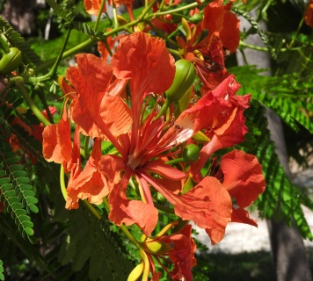
Common English name: Royal poincinia
Local name: Krishnachura (Ass., Beng.), Gulmohar (Hindi)
Description of plants:Perennial tree,stem is upright, woody and cylindrical, covered with smooth barks. Leaves alternate, compound, bippinate, it has 15 pairs of opposite pinnae.Inflorescence terminal clustered. Flower has 5 petals. Fruit seed pod, like woody, flat.
Flowering time: Jan-March ; Fruiting time:Feb-April
Part used: Flower
Medicinal uses:Flower is used in dysenorrhoea; it is also antifungal and antimicrobial.
Other uses:Avenue tree

Botanical name: Bauhinia variegata L.
Synonyms: B. chinensis (DC.) Vogel,B. decora Uribe
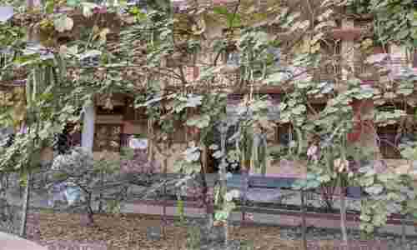
Common English name: Camel foot tree
Local name: Bahurupi kanchan (Ass.), Kanchan (Beng., Hindi)
Description of plants:Small medium sized tree, growing up to 10 -12 m, bark is smooth. Leaves are 10 -12 cm obocordate shape long broad, rounded, bilobes at the apex. Flower conspicuous, bright pink or white, 8-12 cm diameter, with petals. Fruit seed pod.
Flowering time: Jan-April; Fruiting time: April-June
Part used: Leaves and flowers
Medicinal uses:Used in treatment of infectious hepatitis
Other uses:Ornamental

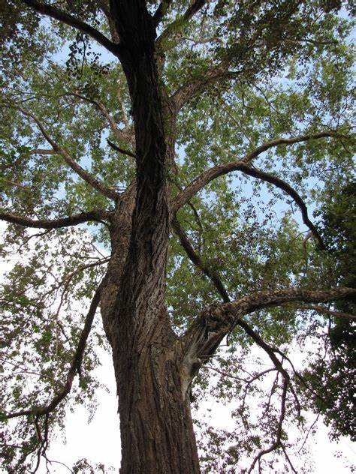
Botanical name: Dalbergia sisso DC.
Synonyms: Amerimnon sissoo (Roxb.) Kuntze
Common English name: Indian Rosewood
Local name: Sissoo (Ass., Beng.), Shisham (Hindi)
Description of plants:Large deciduous tree, rough bark .Leaves are compound, leaflet broadly obovate , stipulet.Inflorescence in an leaf axile panicle , composed of several spikes . Flowers white, sepal cup long, stamen monadelphous, anthers uniform. 2-4 ovulate, style hairless, stigma head like. Fruitlong, strap shaped.
Flowering time: March-April; Fruiting time:April to May
Part used: Bark
Medicinal uses:Bark paste antihelminthic
Other uses:Used as fire wood, timber.

Botanical name: Samnea saman (Jacq.)Merr.
Synonyms: Albizia saman (Jacq .)F.Muell.,Zygia saman (Jacq) A. Lyons
Common English name: Rain Tree
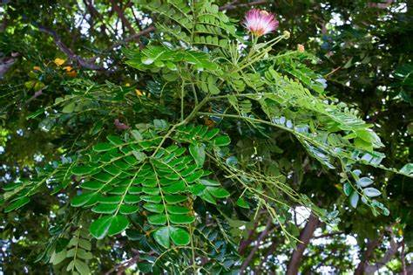
Local name: Bilati siris(Beng.), Vilayti siris (Hindi)
Description of plants:.Deciduous tree, growing up to 20 m tall with broad crown , bark rough , grey .Leaves pinnae 2-6 pairs , leaflet 6-16 pairs ,rhombic- elliptic , assymetric , increasing in size towards top of pinna . Flowers head on 5-10cm long peduncle , calyx approx 6.5 cm long , corolla 13 mm long pink with green lobes; stamen filament white at the base , red at the apex .Fruit fleshy pod ,sweet to taste.
Flowering time: March-April ; Fruiting time:May
Part used: Fruit, Leaves, Bark
Medicinal uses:Adecoctionof inner bark and fresh leaves is used to treat diarrhoea.
Other uses:The pod can be eaten; pulp can be made into drink.

Family-Rosaceae
Botanical name:Rosa indica L.
Synonyms: R. persicifolia Hort. ex Hoffmanns. , R. subumbellata Schur
Common English name: Rose
Local name: Kanta Golap(Ass.), Golap(Beng.), Gulab(Hindi)
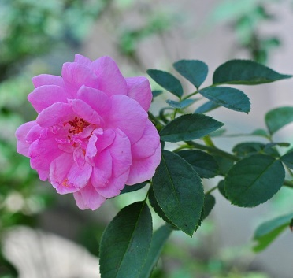
Description of plants:Spiny shrub, 1m tall .Stem erct , branched, woody , prickly . Leaves comound 3-5 leaflet , toothead , opposite , petiolate and green .Flowers solitary , red,5 petals ,free , imbricate, carpel 1 to numerous , synocarpous. Fruit subglobose, fleshy and bright red.
Flowering time:Dec-May; Fruiting time:May-July
Part used: Flowers
Medicinal uses:Flowers are anti depressant, anti spasmodic, aphrodisiac, astringent and increase bile production.
Other uses:Ornamental.

Family-Crassulaceae
Botanical name:Kalanchoe pinnata (Lam.) Pers.
Synonyms: Bryophyllumpinnatum (Lamarck)Oken, Cotyledon pinnata Lamarck
Common English name: Bryophyllum
Local name: Pate goja (Ass.), Pat(Beng.), (Hindi)
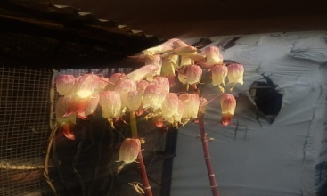
Description of plants:Succulent herb, stem obtusely 4 angled. Leaves variable, decussate,the lower leaves simple , upper leaves 3-5 or 7 foliate ,petiole long , united by a ridge round the stem . Leaflet ovate or elliptic.Inflorescence terminal panicle .Flowers drooping with opposite stout branches.Calyx inflated , cylindric , 4 fid , teeth triangular ;corolla redish purple . Stamen 8, in 2 series, epipetalous , filaments green at the base ,carpels 4 ,green styles . Fruit follicles 4, enclosed in the papery persistant calyx .
Flowering time: January ; Fruiting time:February
Part used: Leaves
Medicinal uses:Juice of leaves useful in kidney stone and treatment of ulcers.
Other uses:Ornamental

Family-Myrtaceae
Botanical name: Psidium guavaja L.
Synonyms: Guavaja pumilia (Vabl) Kuntze, G. pyrifera (L.) Kuntze
Common English name: Guava
Local name: Madhuriaam (Ass.), Piyara (Beng.), Amrud (Hindi)
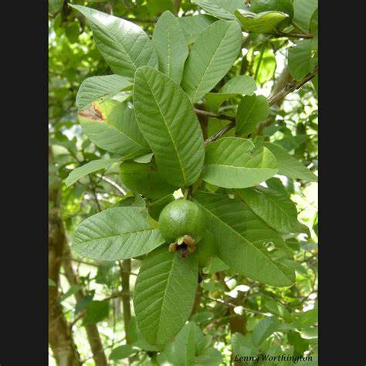
Description of plants:Small trees. Stem smooth with pealing bark. Young stem 4-angled. Leaves elliptic-oblong, base rounded to obtuse-cuneate, apex acute-apiculate
.Cymes axillary, 1-3-flowered; pedicel short. Calyx tube ovoid, densely hirsute; lobes 4, unitedland closed in bud.Petals 4, white, broadly ovate, caducous.Stamen numerous, free.Ovary globose, many-celled; ovules numerous; style subulate. Fruit berry, globose crowned by persistent calyx lobes. Seeds many, embedded in fleshy pulp.
Flowering time: May-June ; Fruiting time:June-July
Part used: Leaves and fruit
Medicinal uses:Leaves used in treatment of stomach pain & diabetes
Other uses:Fruit is edible; pulp is used to make jellies.

Botanical name: Callistemon citrinus (Curtis) Skeels
Synonyms: C. citrinus var. splendens Stapf , C. laevis Stapf
Common English name: Bottle brush
Local name: Bottle brush
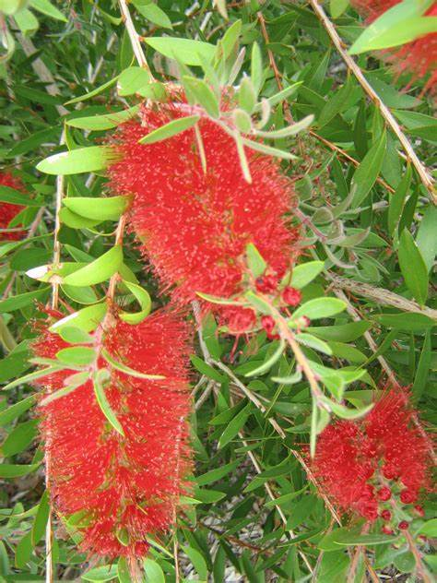
Description of plants:.Large tree. Stem woody but upper portions herbaceous. Leaves ramal and cauline, simple, alternate,entire, acute, gland dotted. Inflorescence pendant spike . Flowers bracteates , complete , hermaphrodite , actinomorphic , pentamerous , epigynous , crimson – yellow to bright red .Calyx composed of 5 sepals , gamosepalous , imbricate ; corolla composed of 5 petals , polypetalous , obovate, quincuncial , small and coloured. Androecium many stamens, polyandrous, filaments long and bright red colour , antherdithecous . Gynoecium is bi to tetracarpellary, generally tricarpellary,syncarpous , inferior , axile placentation , style long and curved , stigma flat. Fruit-capsule .
Flowering time: March-April ; Fruiting time:May-June
Part used: Leaves, Bark
Medicinal uses:Different part of used in diarrhoea,dysentery.
Other uses:Ornamental.

Botanical name: Syzgium cumini (L.)Skeels
Synonyms: S. obovatum (Poir.)DC. , S. obtusifolium(Roxb.)Kostel
Common English name: Black plum
Local name: Kola jamu(Ass.), Jam(Beng.), Jamun(Hindi)
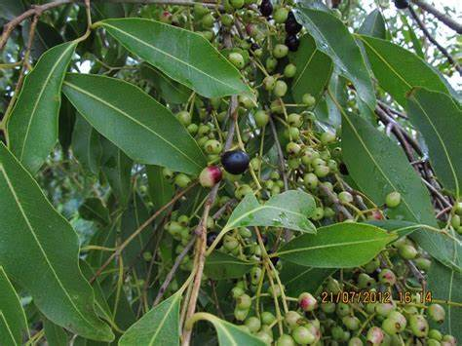
Description of plants:.Evergreen tree, leaves simple , smooth , glossy , elliptic to oblong or ovate . apex acuminate , margin entire . Flowers fragment,small , appear in clusters in a funnel shaped calyx; petals white at first , becoming rose pink in coloure,shading rapidly to leave only numerous stamen. Fruit appear in clustered,round or oblong , dark purple to nearly black in colour.
Flowering time:May-Jun; Fruiting time:Jun-Aug
Part used: Fruit
Medicinal uses:Fruitis natural blood purifier.
Other uses:Fruit pulp is used to make jelly and juices.

Family-Combretaceae
Botanical name: Terminalia arjuna (Roxb.)Wight & Arn.
Synonyms: T.psidiifolia Delile, T. urjn Royle
Common English name: Arjun
Local name: Arjun (Ass., Beng., Hindi)
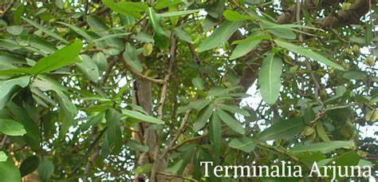
Description of plants:.Large deciduous tree with spreading crown , drooping branches, attains height 35 m ,bark is thick , grey to pinkish,smooth , thin , coming off irregular sheet .Leaves sub-opposite ,base rounded or heart shaped .Flowers sessile and occur in simple panicled spikes ; calyx is glabrous and 5 short triangular lobes. Fruit is fibrous woody drupe.
Flowering time: May to June ; Fruiting time:Jan to Mar
Part used: Bark
Medicinal uses:Bark powder decoctionreduces blood pressure and treats heart diseases.
Other uses:Bark power is used to make tea preparations.

Botanical name: Terminalia chebulaRetz.
Synonyms: T.reticulateRoth, T.zeylanica Van Heurck & Muell Arg.
Common English name: Chebulic Myrobalan
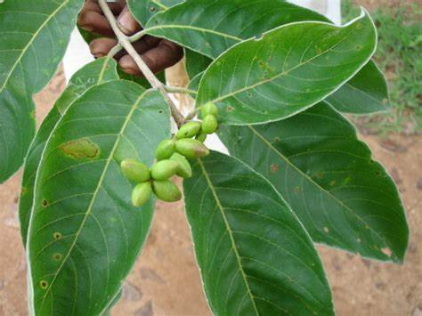
Local name: Hilikha(Ass.),Haritaki (Beng.), Harad (Hindi)
Description of plants: Large tree, stem dark brown. Leaves sub opposite, ovate or oblong. Flowers are yellowish white and emit a strong offensive coloure, they occure in spikes arising from upper axils or in small terminalpanicles. Fruit drupe, yellowish, obovoid or ellipsoid.
Flowering time:May to June; Fruiting time:Nov- Jan
Part used: Fruit
Medicinal uses:Dried fruit powder is helpful in constipation, weight loss, boosts immunity and prevents cough and cold.
Other uses:Powder is used in face mask.

Family-Lythraceae
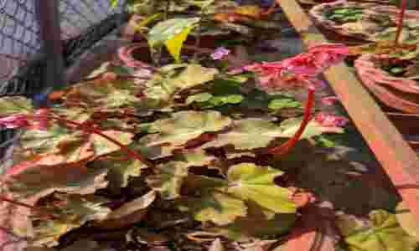
Botanical name: Lawsonia inermis L.
Synonyms:L. speciosa L., L. spinosa L.
Common English name: Cypress shrub
Local name: Jetuka (Ass.), Henna(Beng.), Mehendi patta (Hindi)
Description of plants:Tall shrub. Leaves are grow opposite each other on the stem , sub-ssesile , elliptical and lanceolate . Flowers 4 sepals , calyx tube with spread lobes , petals are ovate ; red stamen in pairs on rim of the calyx tube . Ovary is 4 celled. Fruit small, brownish capsule.
Flowering time:April-May; Fruiting time:July
Part used: Leaves, Bark, Seeds
Medicinal uses:Bark is used as astringent, treat jaundice, leprosy and seeds are used to cure weaknesss.
Other uses:Henna leaves areused as a dye.

Family-Begoniaceae
Botanical name: Begonia malabarica Lam.
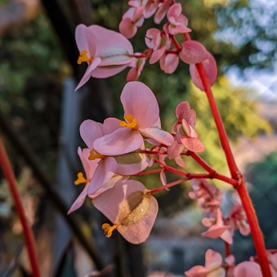
Synonyms: Begonia fallax A.DC. , Begonia hydrophila Micq.
Common English name: Malabar begonia
Local name: Kalpuli(Hindi)
Description of plants:Succulent herb, grow up to 60 cm height.Stems glossy pale green to reddish brown appearence. Leaves toothead with the teeth tipped by a hair otherwise margin strongly wavy, leaves pale to dark pink. Petals are rose pink with white – tinge or pink. Fruit capsule unequally 3-winged.
Flowering time:April-June; Fruiting time:June-Sept
Part used: Whole plant
Medicinal uses:Juice of the plant is drunk to relieve the headache.
Other uses:Ornamental.

Family-Cactaceae
Botanical name: Opuntia ficus-indica (L.) Mill.
Synonyms: Cactus ficus –indica L, Opuntia amyclaeaTen.
Common English name: Prickly pear
Local name:
Description of plants:Slow growing perennial shrub up to 3-5 m high .Root system spread horizontal. Stem very thick succulent, oblong to stipulate. Leaves reduced to thorns,exist on young cladodes. Flowering occurs on 1-2 year old cladodes, yellow and orange, longer than styles and stamen. Fruit is succulent,reddish, ellipsoid.
Flowering time: May ; Fruiting time:June
Part used: Stem and Fruit
Medicinal uses:Sap is used in folk medicines for treating diabetes.
Other uses:Fruit is edible.

Family-Araliaceae
Botanical name:Polyscias fruticosa (L.) Harms
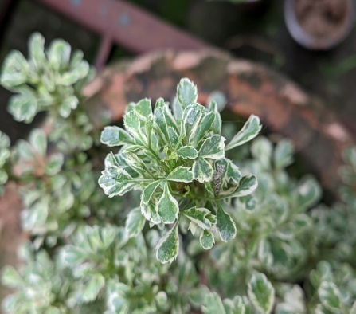
Synonyms:P.fruiticosa var. plumata (W.Bull ex W.Richards) L.H.Bailey ,Tieghmopanax(L.)R.Vig.
Common English name: Ming aralia
Local name: Ming aralia
Description of plants:Slow growing evergreen shrub. Leaves are of dark green pigment, glossy in texture, tripinnate, narrowly ovate to lanceolate.Inflorescence terminal .Flower bisexual, yellow to white in colour. Fruit laterally compressed trignous.
Flowering time:May-June; Fruiting time:June-July
Part used:Roots
Medicinal uses:Rootsare used as diuretic.
Other uses:Ornamental

Botanical name: Polyscias scutellaria (Burm.F.) Fosberg
Synonyms: Araliacochleata Lam., A. rotunda W. Bull
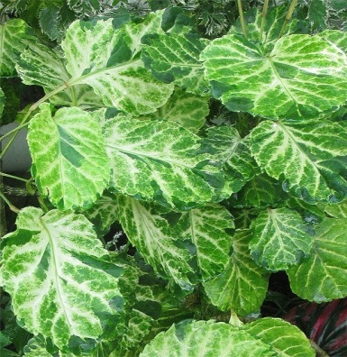
Common English name: Shield Aralia
Local name: Shield aralia
Description of plants:Small trees, 2-6m tall. Leaves 1 or 2 pinnate, leaf stalk 35 – 30 cm enlarged and clasping at the base. alate for 1-6 cm with membranous wing , leaflet 1, 3, or 5 ( rarely 2 or 4 ) , broadly elliptic to obovate , 5-20 to 5-20 cm , papery to subleathery base shallowly heart- shaped or convex , margin subentire to serrates . Tiny flowers occur in erect panicles of umbels,light green to green in colours.
Flowering time:July; Fruiting time:September
Part used: Leaves and roots
Medicinal uses:Leaves and root used as an antiseptic & deodorant.
Other uses:Ornamental

Family-Rubiaceae
Botanical name: Neolamarckia cadamba (Roxb.)Bosser.
Synonyms: Anthocephalus cadamba (Roxb) Miq ,A. indicus var. glabrescens H.L.Li
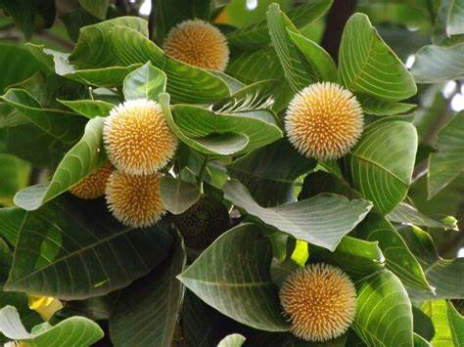
Common English name: Burflower tree
Local name: Kadam (Ass., Beng.), Kadamba (Hindi)
Description of plants:.Deciduous trees, to 20 m high, bark pale brown ; branches horizontal. Leaves opposite, decussate; stipules interpetiolar; lamina, ovate or elliptic-oblong, base truncate or obtuse, apex acuminate, margin entire. Flowers bisexual, yellowish, in globose heads ; calyx tube globose, lobes , membranous; corolla tube long, lobes 5, oblong, acute, glabrous; stamens 5, anthers sagittate, sessile; ovary 2-celled at base, 4-celled above, inferior, ovules many; style exserted ; stigma clavate. Fruit a capsule on a fleshy globose receptacle, orange yellow, capsule membranous; seeds may, angular, minute.
Flowering time:May-June ; Fruiting time:July-September
Part used: Flower, Fruits and leaves
Medicinal uses:Leaf and flower extract are used in treatment of wounds, conjunctivitis, mouth ulcers and doarrhoea.
Other uses:Fruit and flower are edible.

Botanical name: Mussaenda erythrophylla Schumach & Thonn
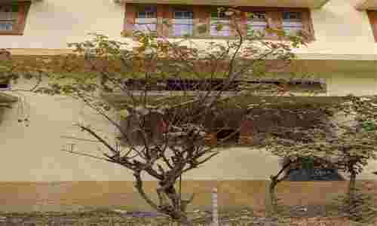
Synonyms: M. fulgens R. Br. Ex Tedile ,M. splendid Welw.
Common English name: Ashanti blood
Local name: Mussaenda (Ass., Hindi, Beng.)
Description of plants:Ornamentalshrub with multiple stem. Leaves opposite, round to ovate, pubsent and strongly veined.Inflorescence terminal, several flowers, branched, corymbose cyme.Flower born on the branching panicles , each flower composed of a small creamish white corolla that is five lobed ,red sepal present .Calyx 5 lobed,one of the lobes enlarged,petal like,ovate lanceolate,lax pendent , bright red above,calyx tube reddish – pubscent;corolla tubular ,5-lobed,red pubscent out side with tube white or pale yellow withi distally.Stamen 5 .Fruit berry..
Flowering time: Mar to May ; Fruiting time:Jun to Aug
Part used: Leaves
Medicinal uses:Leaves used in treatment of laprosy and jaundice.
Other uses:Ornamental

Botanical name: Ixora coccinea L.
Synonyms: I. bundhuca Roxb. ,I. coccinea var. aurerosea Corner
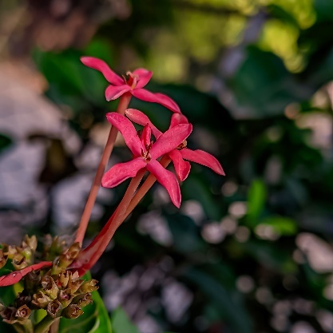
Common English name: Scarlet jungle flame
Local name: Rokto Ronjon(Ass.), Rangan (Beng.), Rugmini(Hindi)
Description of plants:.Bushy shrubs, spreading by root sprouts. Leaves opposite, elliptic to oblong, shortly acute at apex .Corymbs ; peduncle and pedicels short. Small tubeler ,scartlet flower in dense rounded clustered .Flower, bisexual , complete tetramerous , actinomorphic and epigynous . Calyx sepals 4 , green gamosepalous showing valvate aestivation . Corolla petals 4 , bright red or yellow white, gamopetalous showing twisted aestivation , hypocrateriform , corolla tube long and slender. Stamens 4 , epipetalous , attached at the throat of the corolla tube , filaments short , alternate the petals . Anthers are dithecous .Gynoecium ovary inferior, bicarpellary and syncarpous. Ovary bilocular , axile placentation. Style simpleand filiform stigma bifid.Fruit berry.
Flowering time: Feb-May ; Fruiting time:May-June
Part used: Leaves, fruit and root
Medicinal uses:Fusion of leaf and fruit juice is used to treat dysentery, ulcers and gonorrhea. Decoction of the root is used as a sedative
Other uses:Ornamental

Family-Asteraceae
Botanical name: Sonchus oleraceus (L.) L.
Synonyms:S. umbellifer Thunb. , Szacinthoides DC.
Common English name:Hare thistles
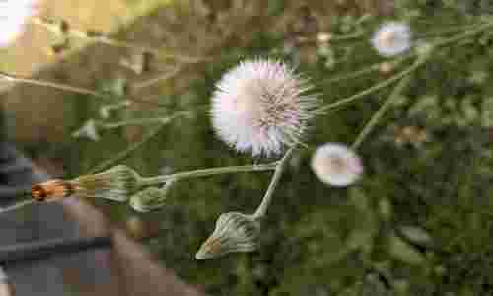
Local name: Dudhi (Hindi)

Description of plants:Erect herb upto 1.5 m in height,underground tap root system . Sinka white latex when cut .Leaves, simple, alternate and sessile.Inflorescence consisting of flower head 2 to 3 cm in diameterstalk long. Flower heads with involucral bracts,all flower are ligulate , bisexcual, yellow colour. bracts are dull green hairless, corolla 5 toothead,tube narrowly cylindrick , stamen 5 , ovary inferior. Fruit and achene compressed, narrow obovate.
Flowering time: October-March; Fruiting time:Nov-July
Part used: Whole plant
Medicinal uses:Juice of the plant used in cleaning and healing ulcers, anti-inflammatory, hepatoprotective.
Other uses:Young leaves are edible.

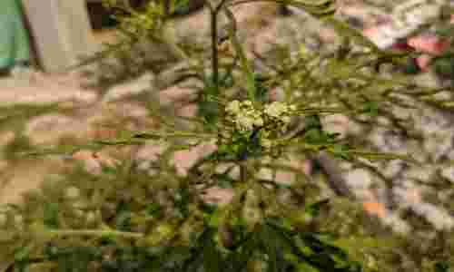
Botanical name:Parthenium hysterophorus L.
Synonyms: P. glomeratum Rollins, P. lobatum Buckley
Common English name: Carrot grass
Local name: Gajar ghans(Hindi)

Description of plants:Short- lived herbaceous plant , mature stems are greenish and longitudinally grooved , covered in small stiff hairs ( hirsute). Leaves are simple , alternate . Numerous small flower- heads (capitula) are arranged in clusters at the tips of branches (terminal panicles). Each flower-head (capitulum) in borne on stalk, they are white or cream colour, 5 tiny petals(ray florets), they also have numerous (12-60) tiny white flowers ( tubular florets)in centre . Seeds (achenes) are black, flattened consists of small scales (a pappus).
Flowering time: October-March ; Fruiting time:Nov-July
Part used: Whole plant
Medicinal uses:Plant juice is used to treat skin inflammation, urinary tract infection and rheumatic pain.
Other uses:Organic green manure.

Botanical name: Eclipta prostrata(L.)L.
Synonyms: Acmella lanceolata Link ex Spreng. , Amellus carolinianus Walter
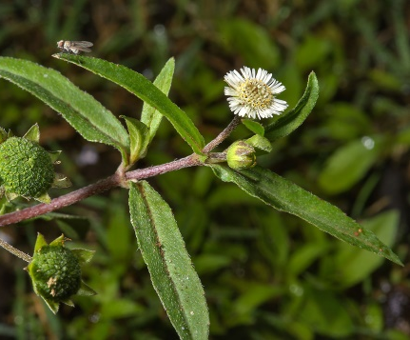
Common English name: False daisy
Local name: Bhringaraj(Ass.,Beng., Hindi)
Description of plants:Annual herb, reddish purple colour stems and have scattered white hairs. Leaves usually opposite, upper leaves may be alternate,sessile, short pedicels . Inflorescence 1 -3 flower head on short pedicel. Flower bisexcual , grouped in a terminal or axillary head and subtended by rings of green bracts , ray florets are white and narrow , short white disk florets are cream or dull white with a small spreading lobes , pale yellow & light brown anthers .Fruit achenes tuberculate , scattered hairs at apex , pappus absent.
Flowering time: January-March; Fruiting time:March-May
Part used: Whole plant
Medicinal uses:Used in treatment of infectious hepatitis, hairfall and dandruff.
Other uses:Young stems are edible.

Botanical name: Calyptocarpous vialis Less.
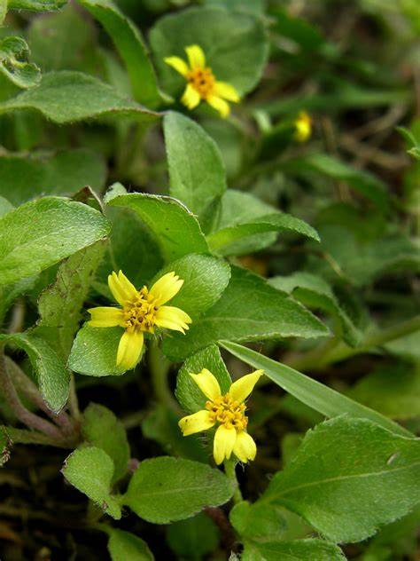
Synonyms: Blainvillea tampicana (D.C.) Benth & Hook. f. ,C. blenpharolepis B.L. Rob.
Common English name: Lawn flower, Straggler daisy
Local name:
Description of plants:.Perennial herb with stemrounded and densely covere with prostrate hairs. Leaves are opposite, ovate, toothead,densely covered with prostrate hair on both surfaces. Flower head are 1/4 inches, yellow flower with around 10-20 disc florets and 3-8 ray florets. Fruit cypsella (achenes)
Flowering time:Sept-Dec; Fruiting time:Nov-Dec
Part used:Leaves and fruit
Medicinal uses:Pulp of the fruit has laxative property
Other uses:Leaves are eaten as vegetables.

Botanical name: Enhydra fluctuans DC.
Synonyms: Coreopsis anagallis (Gardner), Cryphiospermum repens P.Baeuv.
Common English name:Water spinach
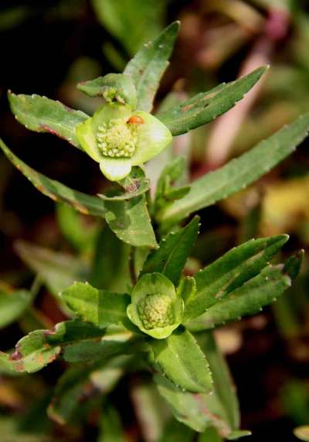
Local name: Helensi(Ass),Helencha (Beng.), Harkuch (Hindi)
Description of plants:A prostrate herb,semi aquatic, glabrous, rooting at the nodes.Leaves opposite & sessile, lanceolate, entire. Inflorescence capitulla axillary,solitary, urn shaped Flower heads terminal, disc florets yellow, ray florets yellow to lemon yellow or white. Fruit achenes brown,narrowly oblong,gland dotted,pappus absent.
Flowering time: Dec- Feb ; Fruiting time:Jan-March
Part used: Whole plant
Medicinal uses:Plant extract is used for treating diarrhea, snakebite.
Other uses:Young plant is eaten as salad.

Botanical name: Crassocephalum crepidiodes (Benth.) S.Moore
Synonyms: C.crepidioides var. lutea Steen.,C. crepidiodies f. luteum (Steen.)Belcher
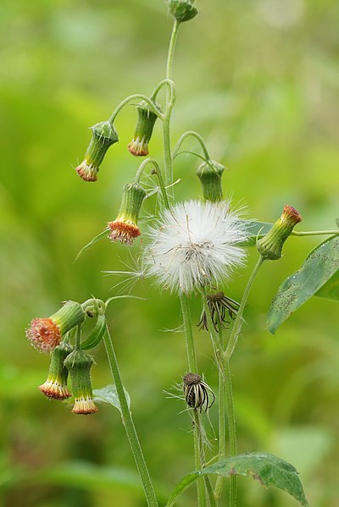
Common English name: Fire weed
Local name: Anikale jhar (Nepali)
Description of plants:Herb up to 1 m tall. Taproot white or brown. Stem rounde or grooved, solid, hairy. Stipules absent. Leaves simple, alternate, spiral, sessile or stalked, glabrous or hairy on both sides, margin coarsely denate, apex acute, base acute, pinnately veined. Flowers are bisexcual, grouped together in terminal head of tubular flowers only, sessile, red or brown. Fruit an achene with pappus.
Flowering time: April ; Fruiting time:July
Part used: Whole plant
Medicinal uses:Lotion of leaves is used as mild medicine which strengthens the stomach muscle.
Other uses: Leaves and stems are eaten as vegetable.

Botanical name: Youngia japonica (L.)DC.
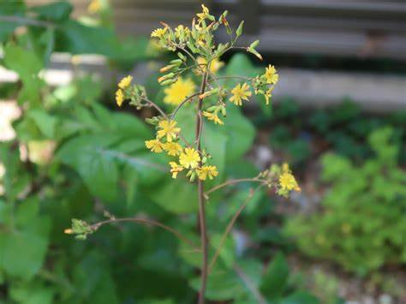
Synonyms: Y. paosa Steud. , Y. striata (Blume)DC. ,
Y. thunbergiana DC.
Common English name: Oriental Hawksbeard
Local name:
Description of plants:Biennial herb growing up to 2 ft tall. Stem solitary. Stem leaves are few, reduced above into bracts. Flower heads are many, yellow, in corymb like panicle. Involucre bracts are 6-8, narrowly oblong, greenand erect. Florets are yellow. Seed pods are brown, fusiform, tip narrowed; pappus white.
Flowering time: Jan-April ; Fruiting time:Feb-April
Part used: Whole plant
Medicinal uses:Leaf paste is used to treat wounds.
Other usesYounr leaves used in salad.

Botanical name: Mikania micranthaKunth
Synonyms: Eupatorium denticulatumVahl,E. orinocense (Kunth) Gomez de la Maza, Mikania alata (G.Mey.) DC.
Common English name: Bitter vine
Local name: Japani lota (Ass.), Libuji lota (Beng.)
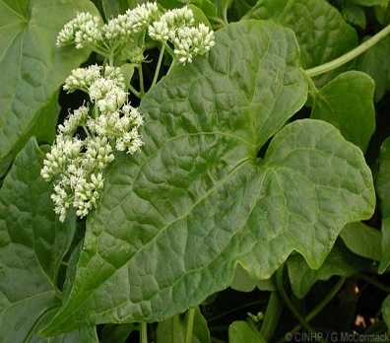
Description of plants:Perennial herbaceous vine, climber. Stem are slender, highly branched and interwined yellowish to brown. The leaf blade is broadly ovate to triangular, acute apex, deeply cordate base, virtually glabrous or under side with sparse hair. Inflorescence formed by small whitish or greenish white flower heads arranged in panicles, twigging bearing composities cymes. Flowersare grouped by small 4 heads whitish to greenish-white, all tubular, ending with triangular lobes. Fruit is black achene.
Flowering time: Nov-Jan ; Fruiting time:Jan-March
Part used: Whole plant
Medicinal uses:Leaves are used for treating stomachache.
Other uses:Young leaves are edible.

Botanical name: Cyanthillium cinereum(L.)H.Rob.
Synonyms: Cacalia cinerea (L.) Kuntze, Conyza cinerea L.
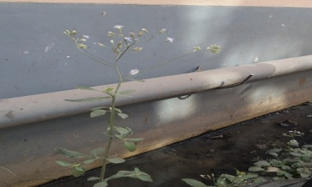
Common English name: Little ironweed
Local name: Sahdevi (Ass.), Kuksim (Beng.), Sahadevi (Hindi)
Description of plants:.A small annual herb with hairy stem. Leaves simple alternate,ovate elliptic or lanceolate, and hairy. Flowers pinkish violet ,in small head forming divaricate terminal corymbs, bract -1 , pappus hairy, corolla equal , regular , tubular , lobes 5, stamen 5, ovary inferior, style bifid, hairy. Fruit cypsella square, oblong, narrow at base hairy.
Flowering time: Nov-April ; Fruiting time:Feb-May
Part used: Whole plant
Medicinal uses:Whole plant is udes to prepare decoction for treating diarrhea, abdominal pain, colic and cough.
Other uses:Young plant is edible.

Botanical name: Ageratum conyzoides L.
Synonyms: A. album Hort.Berol. ex Hornem. ,A. arsenei B.L.Rob.
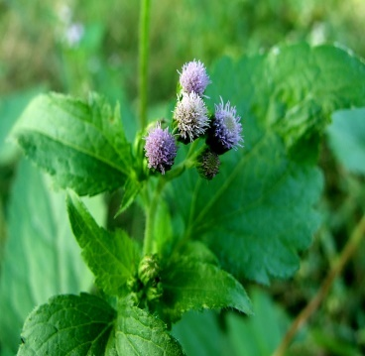
Common English name: Goat weed
Local name: Gendhuabon(Ass.), Uchunti (Beng.), Jungli pudina (Hindi)
Description of plants:Herbs, viscid hairy. Leaves, ovate, apex acute, crenate, base rounded . Heads white, in terminal corymbose panicle; bracts 1-3-seriate, 3-4 mm long, elliptic, toothed at apex, 3-ribbed. Flowers all similar, bisexual; corolla tubular, white, glabrous, 5-lobed at apex; stamens 5, anthers linear. Fruit Achenes , linear ; pappus present.
Flowering time: Oct-Jan ; Fruiting time:Dec-Jan
Part used: Whole plant
Medicinal uses:Plant juice is used to treat fever and headaches, bleedind wounds and burns.
Other uses:Plant decoction is used as hair wash.

Family- Sapotaceae
Botanical name: Mimusops elengiL.
Synonyms: M. parvifolia R. Br., M.timorensis Burck
Common English name:Spanish cherry tree
Local name: Bokul (Ass.), Bakul (Beng.), Maulsari (Hindi)
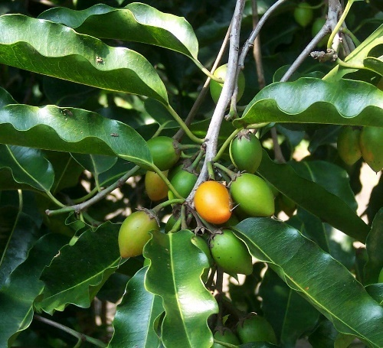
Description of plants:.Evergreen trees, to 20 m high, bark dark grey. Leaves simple, alternate, spiral, stipulate; ; lamina elliptic or elliptic-oblong, base round or obtuse, apex obtuse to acuminate, margin entire . Flowers bisexual, white, fragrant, 1-3 in axillary fascicles ; calyx lobes 8 in 2 series of 4 each , valvate ; petals 9 mm long, lobes with 2 dorsal appendages, corolla 1 cm across; lobes 24, with hairs on back and margins; stamens 8 , anthers oblong ; staminodes lanceolate; ovary , void, hirsute without, 6-8-celled; 1 ovule in each cell; style columner, stigma minutely fimbricate. Fruit a berry, yellow ; seeds oblong-ellipsoid.
Flowering time: April ; Fruiting time:June
Part used: Flower,Fruit and bark.
Medicinal uses:Dried flower powder relieves headache and sinusitis. Bark decoction treats fever and general weakness.
Other uses:Plant extract is used as mouth wash. Fruits are edible.

Family- Oleaceae
Botanical name: Nyctanthes arbortristis L.
Synonyms: Bruchia macrocarpa Ber tol. , Nyctanthes dentate Blume
Common English name: Night jasmine
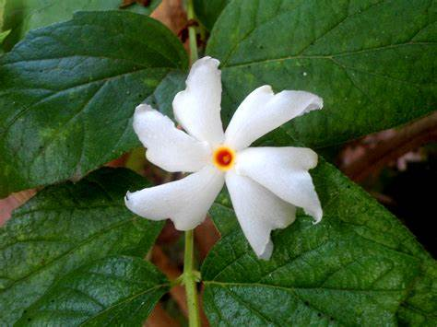
Local name: Sewali phool (Ass.), Sefali phool(Beng.), Harsingar (Hindi)
Description of plants:A deciduous shrub or small tree.Branchlets pubescent, 4-angled. Leaves ovate, shortly acuminate, distantly toothed or entire, base rounded . Flowers white, sweet scented, sessile, 3-7 together on hairy quadrangular peduncles arranged in cymose panicles. Calyx tube funnel shaped, 4-5 toothed; corolla tube cylindrical, orange red, lobes white, 5-8, contorted in bud. Anthers subsesile near the mouth of the corolla tube. Ovary two celled, style cylindric, bifid. Fruit is a compressed orbicular capsule.
Flowering time:Sep to Oct; Fruiting time:Jan to Feb
Part used: Leaves, flower and fruit
Medicinal uses:Leaves are used to treat rheumatism, arthritis, sciatia, fever .
Other uses: Flower and Fruit is edible.

Family- Apocynaceae
Botanical name: Tabernaemontana divaricata (L.) R.Br. ex Roem.& Schult.
Synonyms:T.thailandensis P. T. L. , T. vitiensis Seem.
Common English name: Pinwheel flower
Local name: Kathona ful (Ass.), Jungli tagar (Beng.), Chandni (Hindi)
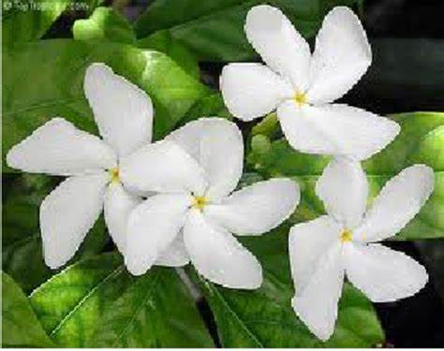
Description of plants:Shrub up to 14 m tall .Leaves twig and petiole produce milky exudate , stipule small ; both upper and lower surface of the leaf blade usually glabrous . Flower white to pale yellow , calyx lobes glabrous corolla tube long , stamen attached middle of the corolla tube , style is long , stigma papillose . Fruit orange , red or yellow with paried follicles..
Flowering time: May-Sept; Fruiting time:Sept-Dec
Part used:Flowers andRoot
Medicinal uses:Root is used to treat the fever
Other uses: Flowers are used for worshipping God.

Botanical name: Catharanthus roseus (L.) G. Don
Synonyms: Vinca rosea var. alba (G. Don ) Sweet , V. rosea var. albiflora Bertol.
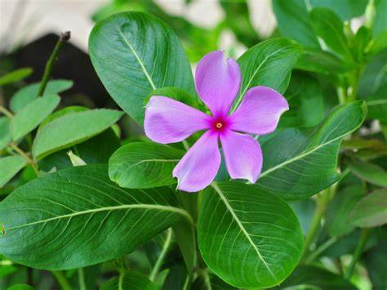
Common English name: Periwinkle
Local name: Nayan tara(Ass., Beng), Sadabahar (Hindi)
Description of plants:Perennial small herb or sub-shrub, up to 90 cm in height. Stem is erect, lax branching with flexible long branches . Leaves are simple, cauline, opposite, ex-stipulate, petiolate, elliptic ovate to oblong .Inflorescence is recemose oraxillary or terminal cyme or solitary/paired and shortly pedicillate. Flower colour is pink/white and tubular, throat of corolla-tube hairy. Androecium contains 5 stamens included in the corolla tube, filaments are very short, epipetalous, anthers forming a cone-like structure. Gynoecium contains two carpels, which are free below, but united in the stylar region. Ovary superior, single short style with dumbbell stigma.Fruit follicles.
Flowering and Fruiting time:Throughout the year
Part used:Whole plant
Medicinal uses:Plant juice is used in treatment of high blood pressure and eye diseases.
Other uses:Ornamental

Botanical name: Plumeria alba L.
Synonyms: P. hypoleuca var. angustifolia Gasp.,P. revolutifolia Stokes
Common English name: Frangipani
Local name: Champa fool (Ass.), Kat golap (Beng.), Gulchin (Hindi)
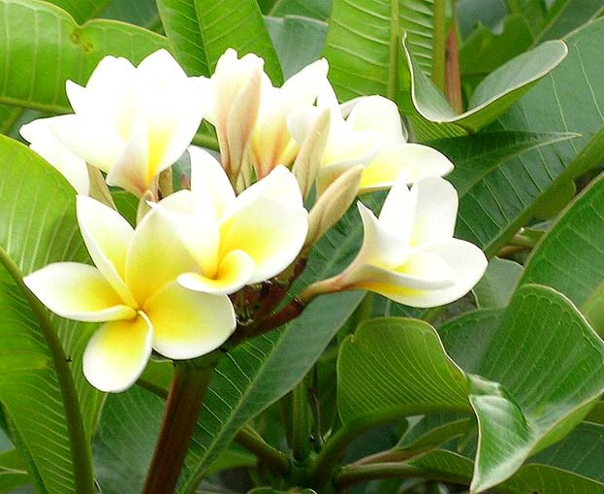
Description of plants:.Small deciduous tree , grow up to 25 feet tall . Branches are thick but weak bear milky sap . Leaves oblong lanceolate , green leaves up to 12 inches long and spirally clustered at stem ends, 5 petal flowers , white coloure with yellow centre. Fruit cylindrical pods
Flowering and Fruiting time:Throughout the year
Part used: Bark and Wood
Medicinal uses:Bark is used in treatment of diaarhoea and gonorrohea
Other uses: Wood is used as firewood, Ornamental.

Family-Convolvulaceae
Botanical name: Ipomea carica (L) Sweet.
Synonyms: I. tuberosa Lour. , I.vesiculosa P.Beauv
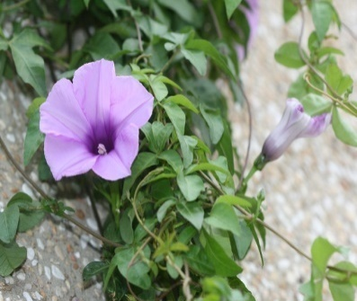
Common English name: Railway creeper
Local name:
Description of plants:.A hairless , slim climber , with bulbous root . Leaves are stalked with 2 to 6 cm long petiole , leaf blade ovate to circular .Flower stalks are 12 to 20 mm long , sepals are ovate and sting pointed and violet coloured . The crown is funnel shaped , 4-6 cm long and violet coloured . Stamen and stylus do not protrude beyond the crown. Ovary hairless.Fruit spherical capsule .
Flowering time: Jan-March ; Fruiting time:March-April
Part used: Whole plant
Medicinal uses:It is highly potent against malaria.
Other uses:Ornamental

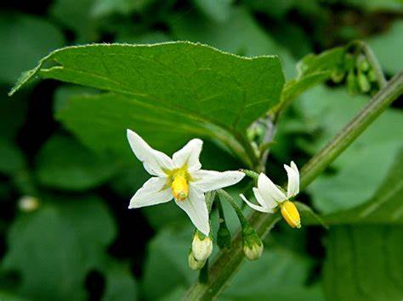
Family- Solanaceae
Botanical name:Solanum nigrum L.
Synonyms: S. atriplicifolium Desp. ex Dunal , S.cuneifolium Hort. Avens ex Dunal
Common English name: Black Nightshade
Local name: Pokmou (Ass.), Mokoi (Beng.), Kakamachi (Hindi)
Description of plants:.Wild annual herb,.Leaves alternate and simple .Inflorescence extra axillary scorpioid cyme known as riphidium .Flowers pedicillate , complte ,actinomorphic ,bvisexcual ;calyx 5 ,gamosepalous valvate ;corolla gamopetalous ,rotate .Androceium 5,polypetalous.Gynoceium bicarpillary ,synocarpous ,style simple .Fruit succulent berry
Flowering time: Jan-April ; Fruiting time:March-May
Part used: Fruits and Roots
Medicinal uses:Juice of the root is used against asthma.
Other uses: Fruits are edible.

Botanical name: Capsicum annumL.
Synonyms: C. ustulatumPaxton , C. violaceum Desf
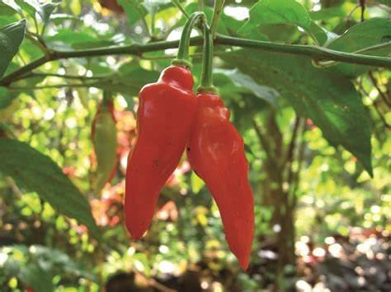
Common English name: Chilli
Local name: Jolokia(Ass.), Lanka(Beng.), Mirchi(Hindi)
Description of plants:.Perennial herb stem densely branched 24 inches tall . Stem irregularly angular to subtereate .Leaves alternate , simple. Flowers usually borne singly , terminal ; calyx cup shaped , corolla campanuculate to rotate with 5 to 7 lobes, 5 to 7 stamen with pale blue to purplish anther,ovary 2 locular ,style filifrom , white or purplish,stigma capitates . Fruit a non-puply berry, very variable in size , shape ; coloure , green , yellow , cream or purplish when immature ,red , orange , yellow , brown when mature.
Flowering and Fruiting time:Throughout the year
Part used: Fruit
Medicinal uses:Mix of red chillies medicated with castor or oil is useful in easing from pain
Other uses:Edible fruit. Used to make pickles.

Family- Plantaginaceae
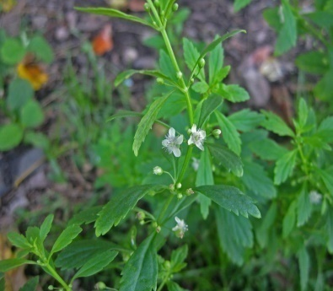
Botanical name: Scoparia dulcis L.
Synonyms: S.purpurea Ridl. , S.ternata Forsk.
Common English name: Sweet broom weed
Local name: Bon Dhaniya (Ass., Beng), Mithi patti (Hindi)
Description of plants:.Erect annual or perennial herbs. Leaves decussate to whorled, obovate-oblong, base attenuate, margin crenate-serrate, apex acute ; petiole long. Flowers axillary, solitary or 2; pedicels slender .Calyx ovate-oblong, ciliate along margin. Corolla white , rotate, throat densely hairy, lobes spathulate. Stamens 4, subequal, .Ovary globose, 2-celled; ovules many; stigma truncate.Fruit capsule.
Flowering and Fruiting time:Through out the year
Part used: Whole plant
Medicinal uses:It is used in diabetes.
Other uses: Whole plant is edible.

Family- Lentibulariaceae
Botanical name: Utricularia gibba L.
Synonyms:U. tenuisvar .poeppigii A. DC. , U. tricrenata Balker ex Hiern
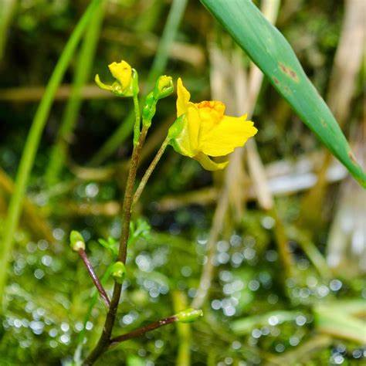
Common English name: Crepping Bladderwort
Local name: Bladderwort
Description of plants:.Loosely rooted (rarely free - Floating ) aquatic or creeping in mud stem . Generally of one kind , thread – like , with leaves , few bladders throughout , winter buds . Leaf 2 to 6 (8) , thread like . Inflorescence 1 to 4 flowered . Flower corolla 6 to 15 ( 25) mm. Fruit laterally 2- valved
Flowering time: July ; Fruiting time:Sep
Part used: Whole plant
Medicinal uses:
Other uses:

Family-Verbenaceae
Botanical name: Duranta erecta L.
Synonyms: D. angustifolia Salisb. , D. baumgartenii K.Koch
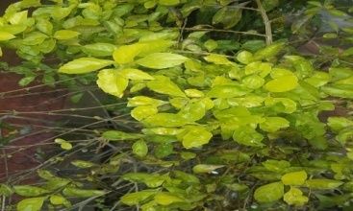
Common English name: Golden Dewdrop
Local name: Duranta kata (Ass.), Kata mehedi (Beng.), Nilkanta (Hindi)
Description of plants:.Shrub, bark dark brown. Branchlets obtusely 4 angular , with spines. Leaves opposite, ovate-elliptic, obovate-oblong, lanceolate or ovate , margin entire to dentate-serrate, apex acute to acuminate , green coloured and sometimes with yellow and white patches near the margins . Inflorescence racemose panicles, axillary, terminal. Flowers zygomorphic, slender, pedicellate about , calyx tubular or subhypocrateriform 5 toothed with acute teeth ,light green colored. Corolla hypocrateriform, unequal 5 lobed, blue, purple and yellowish purple . Corolla tube sparsely hairy on the throat, lateral lobes straight or curved ., Stamens 4, didynamous , filaments filiform, hairy, green colored, anthers creamish, oblong, Ovary globose , style slender about half the length of the corolla tube, glabrous, stigma capitates, shortly 4 lobed. Fruit is drupe,globose, shining yellow.
Flowering time: April-May; Fruiting time:June-July
Part used: Leaves and Fruit
Medicinal uses:Fruits are used as febrifuge, used in treatment of malaria and intestinal worms. Leaf extract is used to treat abscesses.
Other uses:The plant is used as an insect repellent

Family- Lamiaceae
Botanical name: Ocimum tenuiflorum L.
Synonyms: Ocimum sanctum L.
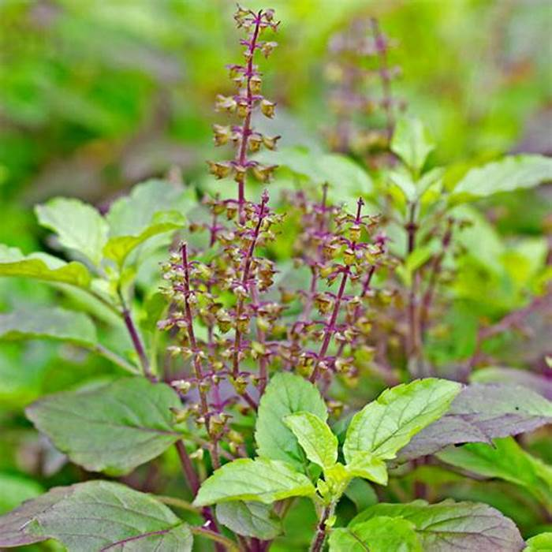
Common English name: Holy basil
Local name: Tulsi (Ass., Beng., Hindi)
Description of plants:Small annual or short lived perennial shrub up to 1 metre height .Stem are hairey and bear simple toothead or entire leaves along the stem.Leaves are simple , petioled with an ovate blade ,which usually has a slightly toothed margin green or purple. Small purple or white tubular flower have green or purple sepals and are borne in terminal spikes. Fruit are nutlets and produce numerous seeds.
Flowering time: March-October;Fruiting time:April-November
Part used: Leaves
Medicinal uses: Leaf extract is used in treatment of cough, fever, acne, insect bites.
Other uses: Worshipped by the Hindus.

Botanical name: Leucas aspera(Wild.)Link
Synonyms: L. dimidiata (Roth) Spreng. , L. minahassae Koord
Common English name: Thumbai
Local name: Durun xak(Ass.), DurunPhul(Beng.), Chota halkusa (Hindi)
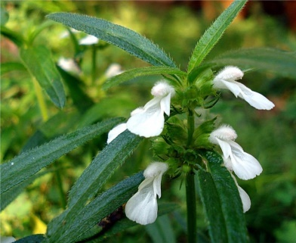
Description of plants:.Annual herb or under shrub reach height 15 – 60 cm . Stem quadrangular . Leaves simple ,opposite and decussate, leaf shape in liniear – lanceolate and leaf apex acute. Inflorescence verticillaster . Flower white , small ,complete ,bisexcual , hypogynous ,pentamerous ; calyx 5 , gamosepalous ,petals 5, gmopetalous , bilibiate ,tube annulate ,lower lip 3 fid ,spreading ,mid lobe large , upper lip 2 fid ,erect ,concave . Androceium stamen 4 , epipetalous , didynamous ,anthers connivent . Gynoceium carpels 2 synocarpous ,axile placentation , style gynobasic , stigma bifid . Fruit nutlet
Flowering time: Sep-Dec; Fruiting time:Jan-Feb
Part used: Whole plant
Medicinal uses:Plant juice helps in reducing fever.
Other uses: Whole plant is is cooked as leafy vegetable.

Family- Nyctaginaceae
Botanical name: Bougainvillea glabra Choisy
Synonyms: B. brachycarpaHeimerl,B. rubicunda Schott ex Rohrb.
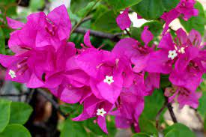
Common English name: Paper flower
Local name: Begunvillea (Ass.,Beng.)
Description of plants:.Evergreen climbing shrub with thick thorny stems and drooping branchlets that sparsely hairy . Leaves are approx 1 cm ,leaf blade ovate – lanceolate ,pointed,bract purple . Glossy leaves are green or variegated,they are generally glabrous(smooth and hairless) . Tiny white flower appear in clustered surrounded by colourful bract. Flower are about 0.4 cm diam (the pink petals like structure are not petals but bract). Fruit is narrow, five lobed, achene.
Flowering time: Nov- May; Fruiting time:Jan-June
Part used: Leaves
Medicinal uses: Leaf juice is used in treatment of Hepatitis.
Other uses- Ornamental

Family- Amaranthaceae
Botanical name: Amaranthus virdis L.
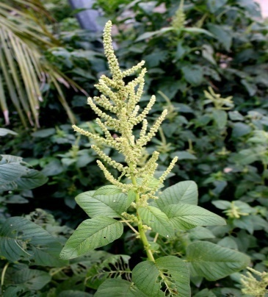
Synonyms:Glomeraria virdis (L.) Cav., Pyxidium virde (L.)Mocq.
Common English name: Amaranthus
Local name: Khutura (Ass., Beng.), Chaulai (Hindi)
Description of plants:.Annual,erect or prostrate herb,80 cm tall ,taproot white or brown . Stem solid. Leaves simple, opposite, stalked, ovate , margin entire ,apex acute . Flowers bisexcual, grouped in a terminal spike, sessile, petals 3, small ,green . Fruitis a capsule
Flowering time: July- Oct ; Fruiting time:Sep-Dec
Part used: Whole plant
Medicinal uses:Treatment of fever, cough
Other uses: Whole plant is eaten as leafy vegetable.

Family-Chenopodiaceae
Botanical name: Chenopodium album L.
Synonyms: C. album var.spicatum w. D. J. Koch. ,C. album f. spicatum (W.D.J Koch) Aellen
Common English name: White goosefoot
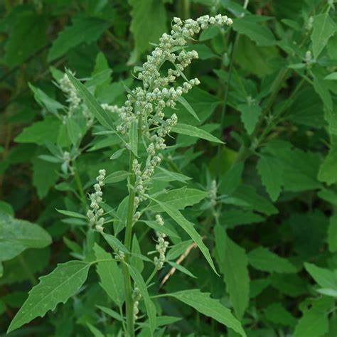
Local name: Jilmil (Ass.), Bathuwa(Beng., Hindi)
Description of plants:.Fast growing weedy annual plant , reach up to 10 -150 cm .Leaves simple alternate oval to obovate or lanceolate shaped . Inflorescence clustered to the leaf axils and terminus of stems .Flowers grouped into dense ball ,small ,green and directly inserted on the stem . Fruits are not visible, they are entirely enclosed in the floral envelope
Flowering time: March- April ; Fruiting time:April-May
Part used: Whole plant
Medicinal uses:Plant extraxt is used in treatment of rheumatism, insect bites, skin problems.
Other uses- The leaves and young shoots of the plant used in dishes such as soups , curries , paratha.

Family-Piperaceae
Botanical name: Peperomia pellucida Kunth
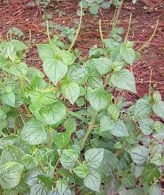
Synonyms: PiperherbaceumMiq.,P. miyosurus Wild.
Common English name: Shiny bush
Local name: Pononoa (Ass.)
Description of plants:.Perennial epiphytes, trailing stems. Leaves are smooth and fleshy and may be oval with the leaf stalk at or near the centre of leaf blade or they may be heart shape or lance shaped, size 1-4 inches. The tiny flowers are unnoticeable, grow in the from of cordlike spikes. Fruit are berry.
Flowering and Fruiting time:Throughout the year
Part used:Whole plant
Medicinal uses:Plant extract is used to treat eye inflammation, wounds, skin boils, high blood pressure.
Other uses:Edible herb.

Family- Lauraceae
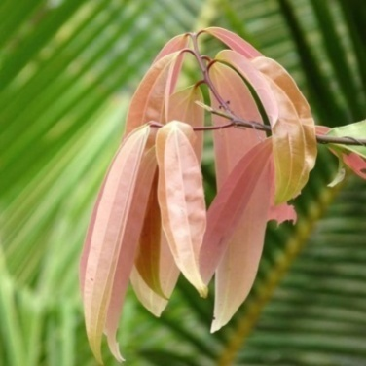
Botanical name: Cinnamomum tamala (Buch ham) Th.G.G.Nees
Synonyms: C. albiflorum Nees,.C.lindleyi Lukmanoff
Common English name: Indian bay leaf
Local name: Tejpat (Ass.), Tejpatta (Hindi), Tejpata(Beng.)
Description of plants:.A medium – sized tree. Leaves –usually 4-5 inches long , very variable in breadth , rarely alternate , shining above , rarely elliptical and obtuse ,when crushed have a strong odour.Flower tiny ,greenish,yellow and small. Fruit drupe.
Flowering time: Feb-May ; Fruiting time:Jun-Oct
Part used: Leaves
Medicinal uses: Leaves strongly effects gastrointestinal system.
Other uses: Leaf used as spice and flavouring agent.

Family-Proteaceae
Botanical name: Grevellia robusta A.Cunn.ex R.Br
Synonyms: G. umbratica A. Cunn. Ex Meissn.,G. venusta A.Cunn. ex Meissn
Common English name:Silver Oak
Local name: Teli wi (Ass.)
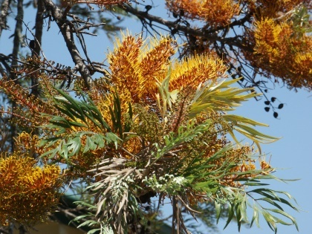
Description of plants:.Straight evergreen tree, 10-25 m tall. Leaves long; leaflets sessile , pinnatifid, olive green coloure above, silver grey silky hairy beneath . Racemes 5-15 cm long, appearing on the old wood, solitary, 2 or a few forming a panicle. Flowers solitary,;. Sepals , hooded, at first all fused together except on one side, later on fused in twos basally and apically, free for the greater length in the middle, these pairs in their turn free from each other or slightly fused above, orange yellow to orange or golden yellow to lemon yellow with dark red inner base. Stamens sessile; connective not produced beyond the anther cells; Disc semi-annular. Gynophore present, ovary glabrous; style lemon yellow . Follicle 2-seeded, , silver grey to olive green, dehiscent
Flowering time: Feb-Apr ; Fruiting time:Sep-Dec
Part used: Leaves
Medicinal uses:Leaf extract is used to treat sores, wounds and skin diseases.
Other uses -Yellow & green dye from the leaves used for dyeing.

Family- Euphorbiaceae
Botanical name: Ricinus communis L.
Synonyms: R. vulgarisMil ,R. zanzibarensis Auct. , R. zanzibarinus Popova
Common English name: Castor plant
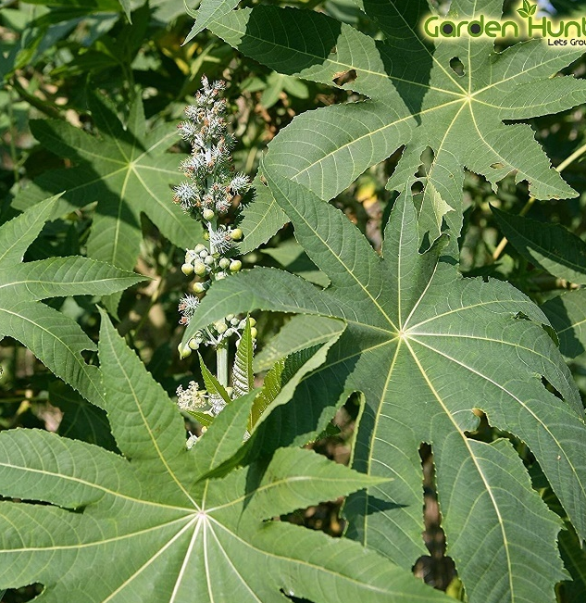
Local name: Era gos (Ass.), Bherenda (Beng.), Erandi (Hindi)
Description of plants:.Shrubs. Leaves alternate, plamately 6-8lobed , lanceolate , margin coarsely serrate , apex acuminate . Flowers in terminal paniculate recemes , pale yellow, male flowers below, female ones above . Male flower perianth cupilar , 3-5 lobed , lanceolate , stamens many , filament connate , repeatedly branched ; female flower tepals 5 , subequal , lanceolate . Ovary globose, 3 locular , styles 3 , paooilose . Fruit iscapsule , spiny , greenish . Seeds oblong , smooth, marbled, carunculate.
Flowering time: Apr-May ; Fruiting time:May-July
Part used: Leaves and seeds.
Medicinal uses:Leaf extract is used in treatment of abdominal disorders, arthritis, backache, rheumatism, insomnia. Seed yield castor oil which is a remedy for hair growth and mucle pains.
Other uses- Leaves are fed to silkworms.

Botanical name: Codiaum variegatum (L.)Rumph.Ex A. Juss.
Synonyms: C.chrysostictonRumph .ex spreng. , C. variegatum (L.) Blume
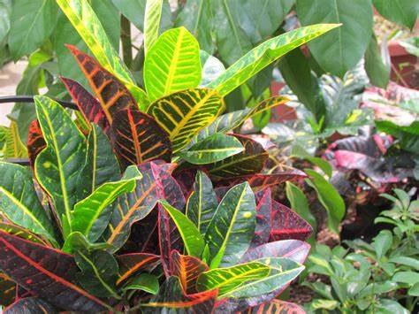
Common English name: Garden croton
Local name: Patabahar(Beng.), Rang birangi Croton (Hindi)
Description of plants:.Evergreen monoceious shrubs and when cut the stems bleed a milky sap. Leaves large thick, leathery, shinning, alternately arranged . Leaf blade lanceolate, ovate and coloured green , yellow or purple . Inflorescence is long racemes.Male flower are white with five small petals and 20 – 30 stamens, female flower yellowish with no petals.Fruit is capsule.
Flowering time: July-Aug ; Fruiting time:Aug-Sept
Part used: Leaves
Medicinal uses: Leaf extract is used to treat stomach ache, external wounds, intestinal worms.
Other uses:Ornamental

Botanical name:Acalypha indica L.
Synonyms: A. bailloniana Mull.Arg. , A. chinensis Benth.
Common English name: Indian Copperleaf
Local name: Muktojhuri (Ass., Beng.)
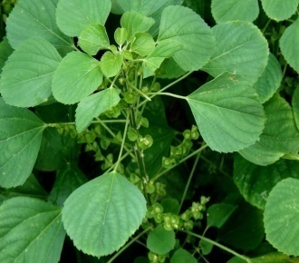
Description of plants:Short lived perennial herb up to 1.5 meters tall . Leaves simple , alternate , ovate , base rounded to shortly attenuate , margin crenate – serrate , apex acute or obtuse . Inflorescenes catkin like.Flower unisexcual , axillary spikes , monoceious, male flower above , female flower below subtendended by foliaceous. Fruit capsule , 3 valved concealed by bract , hispid
Flowering time: April-July ; Fruiting time:June-Oct
Part used: Whole plant
Medicinal uses:Plant juice is used to eliminate intestinal worms.
Other uses:Young plant is edible.

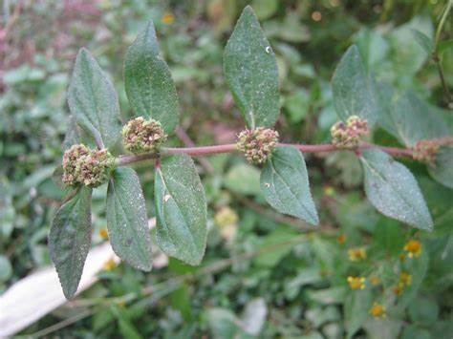
Botanical name: Euphorbia hirta L.
Synonyms: E. pilulifera f. virdis Domin, E. verticillata Vell.
Common English name: Asthma plant
Local name: Gakhiroti bon (Ass.), Barokarni (Beng), Bara dudhi (Hindi),
Description of plants:A hairy, annual herb . Stems are semi erect from woody tap root, covered with purplish – brown hairs and exude white latex when cut. Leaves are opposite narrowly ovate in shape. Inflorescence cymes collected in dense axillary or terminal clustered. Flowers small, unisexcual, staminate and pistilate , greenish assembled in the same involucres which is cup shaped, 4 toothead at the top, , teeth alternating eith minute glands. Fruit capsule globose, covered with very short hairs. Seed are red brown.
Flowering time: March-April ; Fruiting time:June-July
Part used: Whole plant.
Medicinal uses:Plant juice is used in treatment of breathing disorders.
Other uses:Young plant is cooked as vegetable.

Botanical name:Euphorbia mili des moul
Synonyms: E. breonii Noiss nom. Illeg. , E. mili var breonii (Nois.)Ursch &Leandri, nom.inval.
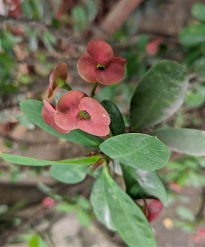
Common English name: Crown of Thorns
Local name: Konto mukut (Beng.)
Description of plants:.Small annual shrub ,fleshy stem with long spines. Leaves \alternate , clustered at stem apex , stipules forming spines , leaf blade ovate to oblong , base attenuate , margin entire , apex rounded. Cyanthia in subapical , dichasial cymes , cyanthophylls 2 , reniform rounded,usually rounded involucre campanuculate , lobes 5 , lanceolate , glands 5 , reniform – rounded . Male flowers many, bracteoles linear, apex pilose; female flower ovary smooth , glabrous, usually included with involucres , styles connate below middle , stigma 2 lobed. Fruit capsule 3 lobed-ovoid, smooth and glabrous. Seeds are ovoid.
Flowering time:Feb-May; Fruiting time:May-June
Part used:Leaves
Medicinal uses:Leaf juice used for treatment of warts.
Other uses:Ornamental

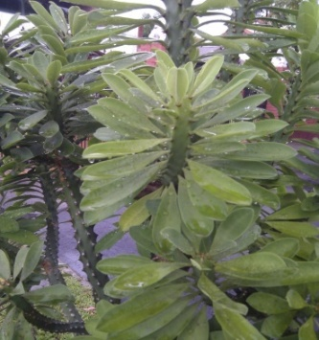
Botanical name:Euphorbia nerifolia L.
Synonyms: E. nerifolia (L.)A.Chev.,E. edulis Lour. , E. ligularia Roxb. Ex Buch – Ham
Common English name: Indian spurge tree
Local name: Siju (Ass., Bodo), Sehund (Hindi)
Description of plants:.Shrub, 3-5 m tall , hairless except cyathia . Stem 6-15 cm thick , green , branching from upper part . Leaves are alternate , apically clustered and fleshy , spine shields small, stipules prickle like. Inflorescnce is cyathium type. Male flowers are many , bracts linear . Female flower rarely developed, involucres bell shaped. Fruit capsules.
Flowering time: April-May ; Fruiting time:May-June
Part used: Leaves
Medicinal uses:Fresh diluted latex is used as purgative.
Other uses:Plant is worshipped by the Bodos.

Family: Moraceae
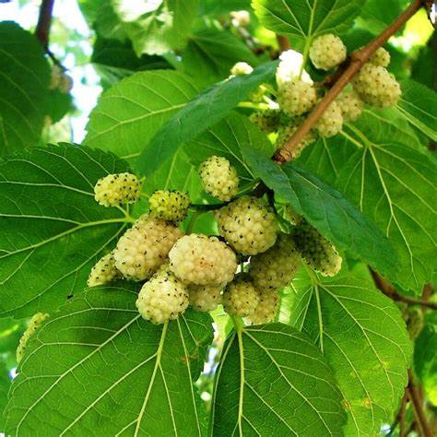
Botanical name:Morus alba L.
Synonyms:M. venassaini Hort. ex Steud. , M.venosa Del. Ex Spach
Common English name: White mulberry
Local name:Nuni(Ass.), Tut (Beng), Sahtut (Hindi)
Description of plants:.A deciduous, tall tree . Trunk with dark grey-brown, rough, vertically fissured bark . Leaves with a crisped hairy, filiform . Lamina narrow to broad, ovate, margin regularly serrate or crenate-serrate or irregularly 2-serrate, apex obtuse, acute or shortly acuminate . Stipules are oblong , leaving the semi circular scar , brownish membranous and hairy. Male catkins long including slender, hairy peduncle, with lax flowers. Male flowers: Sepals free, broadly ovate , cucullate, obtuse, glabrous to hairy; staminal filaments equal to sepals, with ovate, exserted anthers. Female catkins ovoid, long, with out equally long or slightly longer peduncle. Female flowers sepals suborbicular, c. as long as or slightly larger than of male flowers, glabrous or ciliate on margins; ovary with glabrous free styles
Flowering time:Mar- Apr; Fruiting time:Jun-Aug
Part used: Fruits and leaves.
Medicinal uses:Used in treatment of dizziness, insomnia, premature ageing.
Other uses:Leaves are used to feed silkworms, fruits edible.

Botanical name: Ficus benghalensisL.
Synonyms: F. banyanOken ,F.chauvieri G. Nicholson
Common English name: Banyan tree
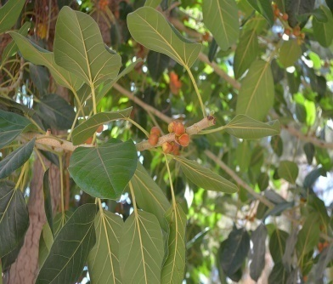
Local name: Ahot(Ass.), Peepal (Beng., Hindi)
Description of plants:.Tree, 40 m tall monoceious , hemi epiphytes , aerial prop root numerous , forming accessory trunk and helping in the lateral spreading . Bark grayish white , smooth . Leaves alternate, often clusters at the end of branches , lamina ovate to elliptic . Figs paired , axillary , sessile, initially enclosed in calyptrate up to 1cm long , leathery bud covers , receptacle globose to sub globose , bright red or orange red when ripe. Achenes ovoid, trignous.
Flowering time: Mar-April ; Fruiting time:Mar-May
Part used: Leaves
Medicinal uses:Leaf paste is used to treat wounds, skin diseases, eye diseases.
Other uses:Leaves and twigs are fooder for cattle.

Botanical name: Ficus elastica Roxb.
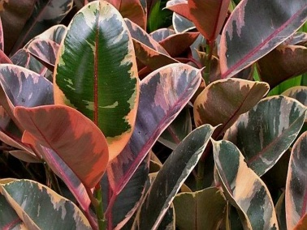
Synonyms: F. clusiifoliaSummerhayes, F. cordata Hot. Berol.ex Kunth & Bouche.
Common English name: Rubber plant
Local name: Rubber gos (Ass.), Rubber gach (Beng.,Hindi)
Description of plants:Treegrows up to 30 to 4o m tall. Broad shinny oval leaves , leaves develop reddish tip at the branches. Small stalk less, yellow green oval figs, 1cm long,grow in pairs
Flowering time: March-May ; Fruiting time:May
Part used: Fruits
Medicinal uses:Fruit is used as laxative.
Other uses:Plant yields latex which is used to make commercial rubber.

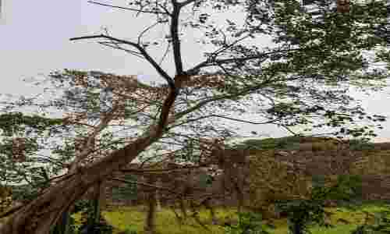
Botanical name: Ficus retusa L.
Synonyms: F. truncata (Miq.) Miq.,Perularetusa (L.) Gasp.
Common English name: Indian laurel fig
Local name: Jori bor (Ass.), Pakur (Beng.), Kamrup (Hindi)
Description of plants:.Medium sized evergreen tree, often epiphytic, forming a tangled mass with aerial roots and horizontal branches. Bark grayish .Leaves ovate-elliptic or rhomboid, entire, acute or short-acuminate, entire, coriaceous, glabrous. . Male flowers numerous, perianth segments 3, oblanceolate, spathulate, stamens 1. Gall flowers-perianth segments 3, Female flowers perianth minute, ovary smooth. style short, stigma clavate or cylindric. Receptacle 2-3 in. across, sessile. Syconus fruit in pairs, axillary, sub-globose, yellowish when ripe, with 3 broad ovate persistent basal bracts. Achenes ovoid or obovoid.
Flowering time: March ; Fruiting time:May
Part used:Fruits,Roots and Leaves
Medicinal uses:–Roots and leaves paste applied to wounds.
Other uses:Young fruits are edible.

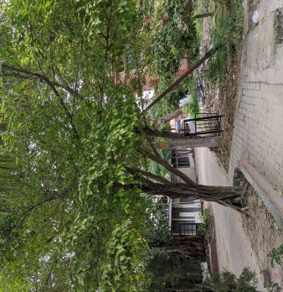
Botanical name: Ficus semicordata Buch.-Ham. ex Sm.
Synonyms: F. hapalophyllaKurtz , F. semicordata var. conglomerate (Roxb.)
Common English name: Drooping fig
Local name: Tokou asing(Ass.), Khunia (Hindi)
Description of plants:.A small to medium sized tree.up to 15 m tall , with an irregular crown . Trunk is up to 2 m in circumference , without aerial roots. Bark is dark – grey . Leaves are carried on 1-1.5 cm long stalks .Leaf blade is veriable , mostly elliptic to oblong . Leaf margin is entireor coarsely toothed . Tip is tapering , and the leaves are slightly rough on both sides or hairy beneath . Figs are spherical to pear – shaped , pink or dull reddish brown with white spots , hairy on learfless branches.
Flowering time: May-Sept ; Fruiting time:Oct
Part used:Leaves,Bark,Fruit
Medicinal uses:Leaves,bark extract is used in treatment of fever,ulcer.
Other uses:Fruits edible.

Botanical name: ArtocarpousheterophyllusLam.
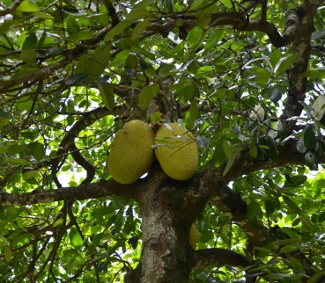
Synonyms:
Common English name: Jackfruit
Local name: Kothal (Ass.), Kathal (Beng.,Hindi)
Description of plants:Evergreen trees to 25 m high, bark blackish-grey; exudation milky white latex; . Leaves simple, alternate; stipulet; lamina obovate, obovate-oblong, or elliptic-ovate, base acute, round or cuneate, apex acute or obtuse, margin entire . Stipules are oblong or lanceolate, leaving the annular scar. Flowers unisexual, minute, yellowish-green, in spikes enclosed by spathe-like bracts, male from young branches, catkin narrow-cylindric; perianth 2-lobed, puberulous; stamen 1; filament somewhat flattened, stout; anthers ovate-oblong; female catkins from the trunk and mature branches, more massive, perianth with strongly projecting conical apex; ovary superior, globose-obovoid; style exserted; stigma spathulate. Fruit a sorosis oblong, tuberculate, tubercles conical yellowish-green, fruiting perianth yellow to light orange, fleshy; seeds elliptic-oblong, smooth, glossy.
Flowering time: Marh-June ; Fruiting time:May-July
Part used: Leaves, Bark and Fruit.
Medicinal uses: Leaf extraxt is used for treating wounds, ulcers and bark powder is used fo treating asthma.
Other uses:Both fleshy pod and seed are eaten.

MONOCOTS

Family:Hydrocharitaceae
Botanical name:Hydrilla verticilliata (L.f.)Royle
Synonyms: Elodea verticilliata(L.f.)F.Muell.,Hydora ilthuanica(Rchb.)Besser
Common English name:Esthwaite waterweed.
Local name: Pani birina (Ass.), Jhangi (Beng., Hindi)
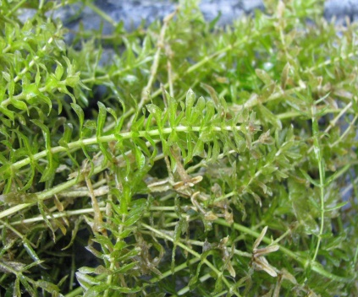
Description of plants:Caulescent, glabrous, profusely branched freshwater herb .Leaves oblong-linear to lanceolate, green, margin serrate-dentate, apex acute-apiculate; nodal scales 2, axillary, membranous with orange brown cilia on margin. Male spathe 1.25-1.50 mm long, bursting open to liberate male flower, beset with subulate appendages. Male flower: sepals reflexed, 1.5-3 mm long; petals linear-spathulate, equalling the sepals, patent or reflexed, obtuse; stamens with minute filaments. Female spathe long, reddish-brown striped, bidentate. Ovary oblong, long slender rostrum.Fruits terete, 5-7 mm long.Seeds dark brown.
Flowering time: December ; Fruiting time:January
Part used: Whole plant
Medicinal uses:Plant is nutritious,improve digestion.
Other uses:Edible

Family: Orchidaceae
Botanical name: Paphiopedilum farrieanum(Lindl.)Stein
Synonyms: P. fairrieanum var. giganteum Pradhan,P. fairrieanum var. nigrescens Pradhan
Common English name: Lady’s slipper orchid
Local name: Lady’s slipper orchid
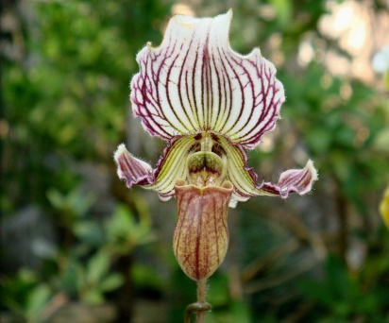
Description of plants:Terrestrial, leaves arranged in a fan on a short stem,4-8, liniear – ligulate,unequally minutely tridenticulate at obtuse or rounded apex,serrulate on margin towards apex ,mid green to dark green ,faintly molted on upper side,paler green below. Inflorescence 1- (or rarely 2-) flowered; peduncle long,slender ,light green ,covered with purplish hair,bract elliptic. Flower small to large,showy ,sepals white,veined green and purple,suffused purple on dorsal surface,petals similar,lip yellow green to olive with darker veining , staminode yellow ,veined greenand purple in centre.pedicel and ovary long ,purple and purple hairy.dorsal sepal ellipticobtuse.Synsepal ovate , rounded at the apex.Petals reflexed – decurved ,S-shaped,narrowly oblong,acute;lip deeply slipper shaped,shortly apiculate and outcurved at the apex. Staminode elliptic,tridentate at apex .
Flowering time:Dec-Feb; Fruiting time:Jan-March
Part used:Flowers
Medicinal uses:
Other uses:Ornamental plant with high demand.

Botanical name: Colegyne viscosa Rchb.f.
Synonyms: C. graminifolia C.S.P.Parish & Rchb.f., Pleione gsraminifolia (C.S.P.Parish & Rchb.f.) Kuntze
Common English name: The sticky Coelogyne
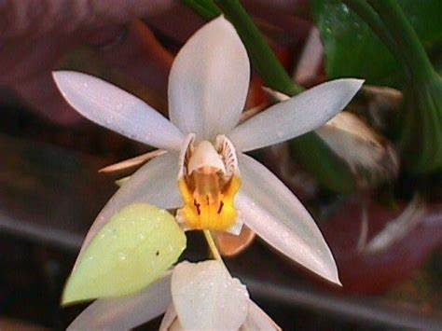
Local name:
Description of plants:Epiphytic on tree trunk in dense humid evergreen forest.Pseudobulbs narrowly ovoid or fusiform.Leaves 8- 12 mm, patioled liniear or lanceolate . Inflorescence raceme, apex enclosed in large bract, usually several flower .Sepals and narrower petals liniear - lanceolate , white , lip very broad rounded, side lobes stereaked with brown , midlobe small ovate , disk with 3 crenulate lamellae from the base to the midlob. .
Flowering time: April-May ; Fruiting time:May-June
Part used:
Medicinal uses:
Other uses:Ornamental.

Botanical name: Cymbidium aloeifolium (L.)Sw.
Synonyms: EpidendrumaloifoliumL. ,E. pendulum Roxb
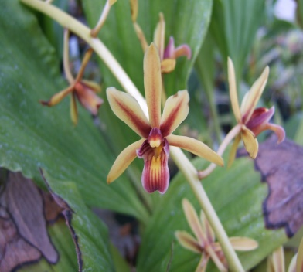
Common English name: Aloe leaf Cymbidium
Local name: Mota – kopou – ful (Ass.)
Description of plants:Epiphyte on the trunk in dense humid evergreen forest. Pseudobulb ovoid, ellipsopid. Leaves several to many/ distichous,usually liniear . Inflorescence erect to pendulous, arising from the base of pseudobulb. Flower are large size, 4 – 5 across , slightly fragment ; sepals & petals pale yellow to cream yellow with broad central maroon brown stripe. Labellum 3 lobes, sessile .Pollinia 2.
Flowering time: Mar ; Fruiting time:May
Part used:
Medicinal uses:Traditionally used in treatment of fever and chronic illness
Other uses:

Botanical name: Eria paniculata Lindl.
Synonyms: Mycaranthes monostachya (Lindl.) ,Pinalia monostachya(Lindl.)
Common English name: Eria
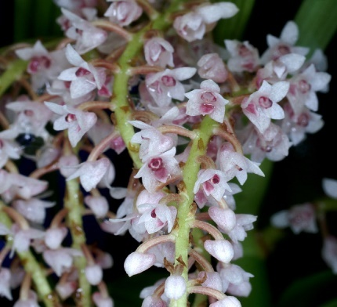
Local name:
Description of plants:Plants are perennial , epiphytic with often pendent woody stems , pseudobulbs cane like , enveloped by tubular sheaths and carrying many all along the stem which are leafy with linear to liner – oblong , acuminate , fleshy , shortly petiolate base leaves the blooms in the winter through spring on 2 to 4 , terminal panicles . It produces densely many flowered inflorescence with acrid smelling flowers.
Flowering time:Aug ; Fruiting time:Sep
Part used: Flower
Medicinal uses:
Other uses:It is ornamental plant with high demand

Botanical name: Pholidata imbricata Hook.
Synonyms:P. barcteata(D.DON) Seidenf,P. imbricata var. platyphylla Scltr.
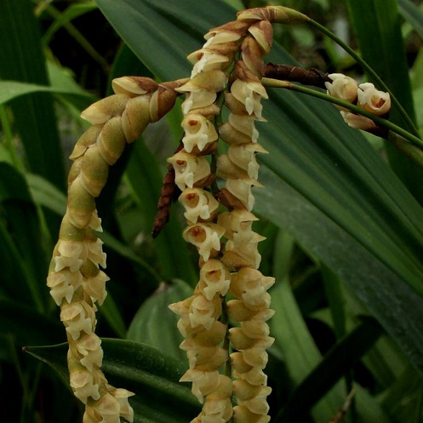
Common English name: Necklace orchid
Local name:
Description of plants:Growing on trees, with crowded pseudobulb and clustered root, pseudobulb oblong conical. Leaves are 1-2 from the tip of pseudobulb, elliptic – inverted – lanceshaped, base narrowed, tip pointed or blunt. Raceme drooping, in the leaf axils. Flowers are pinkish - white, hidden by overlappingleaf like persistant bract. Seplas suequal, ovate, tip blunt, 3- nerved. Petals linear oblong, lip 8 mm , depeply saccare. Column round –ovate. Anthers 2 loculed, pollinia 4. Capsule is ellipsoid.
Flowering time: July-August; Fruiting time:September
Part used: Leaves
Medicinal uses:Leaf extract is used to treatstomach disorders
Other uses:Ornamental

Botanical name:Aerides multiflora Roxb.
Synonyms:A. affinis Wal.ex J. Lindl. ,A. godefroyana Rchb.f.
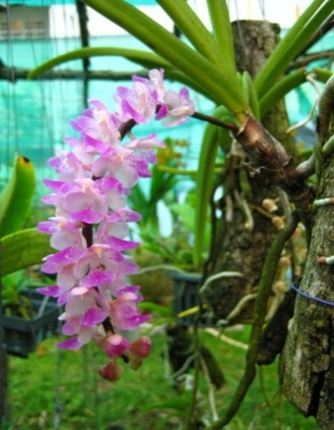
Common English name: Multi flower aerides
Local name: Ronga kopou ful (Ass.)
Description of plants:Epiphyte. Leaves flushed with reddish tinge, oblong, recurved, tapered to the bifid apex, long about 10 to 18 cm in length. Racemes longer then the leaves, simple, axillary, many flowered. The peduncle long and with distant short sheaths. Flowers beautiful, rose coloured, sepals and petals are often with irregular dark spots of the same colour, lip with dark coloured veins, all with paler margins. Sepals and petals sub-equal, oblong, blunt. Lip twice as long as the sepals, entire, triangular.
Flowering time: May to Jul ; Fruiting time:June-July
Part used: Flowers and leaves
Medicinal uses:Juices of leaves heal boils in ear & nose
Other uses:Ornamental

Botanical name: Aerides odorata Lour.
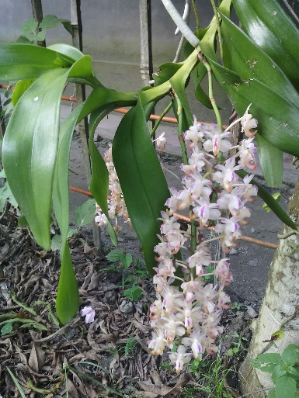
Synonyms: A. ballantinianaRchb.f. ,A.cornuta Roxb
Common English name: Fox brush orchid
Local name: Boga kopou phul (Ass.)
Description of plants:Stems rather drooping, stout, branched. Leaf blade broadly lorate, thickly leathery, obtuse and unequally bilobed. Inflorescence numerous, nodding, racemose, densely 20-30-flowered; floral bracts broadly ovate, obtuse. Flowers fragrant, opening widely, purple to almost white, often tipped and spotted purple, spur apex greenish yellow; pedicel slender. Dorsal sepal elliptic, obtuse-rounded; lateral sepals broadly ovate, adnate at base to column foot, apex obtuse. Petals subelliptic, base contracted, apex obtuse; lip immovable, spurred, 3-lobed, almost enclosing column; lateral lobes erect, obovate-cuneate, distal margin irregularly toothed, apex obtuse-rounded; mid-lobe linear, bilobed; spur bent forward, narrowly horn-shaped, column thick.
Flowering time: April-May; Fruiting time:June- July
Part used: Flowers
Medicinal uses:
Other uses:Ornamental.

Botanical name: Dendrobium aphyllum (Roxb)C.E.C.Fisch.
Synonyms: Callistaaphylla (Roxb.)Kuntze,Cymbidium aphyllum (Roxb.)Sw.
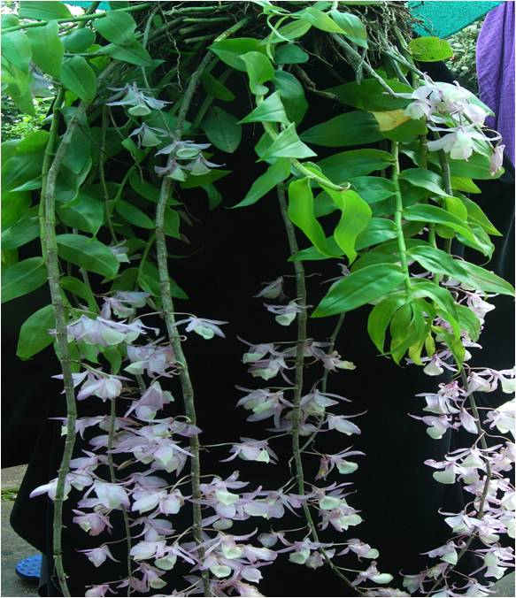
Common English name: Hooded orchid
Local name: Haliki – thulia – phul (Ass.)
Description of plants:.Epiphtic , leaves are deciduous . Stems long , pendulous. Inflorescence originate from the leaf axils,it is short ,sepals petals purple colure,lip is trumplet and yellow in coloure ,covered with hairs
Flowering time: March – April; Fruiting time:April-June
Part used: Whole plant
Medicinal uses:Plant extract is used in treatment of stomach disorder.
Other uses:Ornamental

Botanical name: Dendrobium nobile Lindl.
Synonyms: D. nobile virginale Rolfe, D. wallichianum B.S.Williams
Common English name:
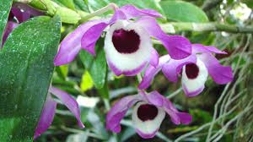
Local name:
Description of plants:.Stem erect , cylindric,10 to 60 cm ,stout,unbranched. Leaves oblong. Inflorescence arising from the old stems before or after leaves fallen . Flowers is large , white and purple coloure.Lip purple at the tip,coloumn green ,anther cap purplish. Petals broadly ovate.
Flowering time: Dec-Jan ; Fruiting time:Jan-Feb
Part used:Whole plant
Medicinal uses:The plant extract is a source of tonic,astrigent
Other uses:Ornamental

Botanical name: Dendrobium jenkinsii Wallich ex Lindley
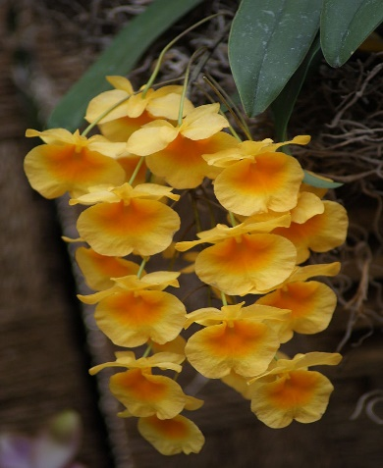
Synonyms: D.aggregatum var. jenkinsii (Wall. ex Lindl.)King & Pantl. , D. marseillei Gagnep.
Common English name: Jenkins’s dendrobium
Local name:
Description of plants:Stem pseudobulbs. Inflorescence lateral from pseudobulb ,shorter than or nearly as long as stem,1-3 flowered, floral bract lanceolate. Flowers uniformly fromyellow orange. Dorsal sepal oblong- elliptic ,lateral sepal narrowly ovate. Petals elliptic - ovate to orbicular ,lip transvesly cordate or biloped lip
Flowering time:April; Fruiting time:May
Part used: Flowers
Medicinal uses:
Other uses:Ornamental.

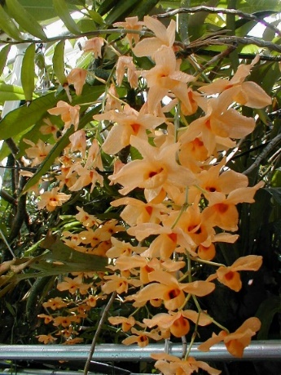
Botanical name: Dendrobium moschatum (Buch.-Ham)Sw.
Synonyms: D.moschatum var.unguipetalum I.Barua ,Epidendrum moschatum Buch.-Ham.
Common English name: Musky smelling dendrobium
Local name: Halodhiya kopou (Ass.)
Description of plants:.Stems erect, cylindric, rigid, unbranched, with many nodes internodes. Leaves alternate along upper part of stem, oblong to oval-lanceolate, leathery, base with clasping papery sheaths, apex acuminate or unequally bilobed. Inflorescences racemose, on old leafless stems, pendulous, several to more than 10-flowered; basal sheaths 4, overlapping, cupular; floral bracts oblong, leathery, apex obtuse. Flowers deep yellow, disk with a pale purplish brown blotch on either side, column yellow, anther cap purple. Dorsal sepal oblong, 7-veined, apex obtuse; lateral sepals oblong, 5-veined, base slightly oblique, apex slightly acute; mentum conic, short and wide . Petals obliquely broadly ovate, 7-veined, apex obtuse; lip rounded, slipperlike , abaxially glabrous, adaxially densely pubescent, margin involute and cucullate. Column , foot present; anther cap conic, adaxially glabrous, front margin irregularly denticulate.
Flowering time:April-May ; Fruiting time:May-June
Part used: Whlole plant
Medicinal uses:Plant extract lowers the blood pressure
Other uses:Ornamental

Family- Musaceae
Botanical name: Musa paradisiaca L.
Synonyms:M. sapientum var. vittata (W.Ackm.ex Rodigas)Hook.f. , M. vittata ex Rodigas
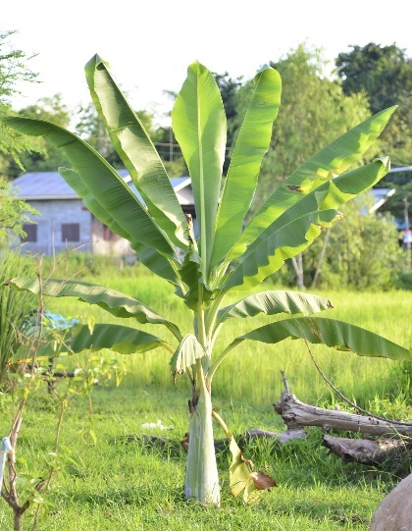
Common English name: Banana
Local name: Jahaji kol (Ass.), Kola (Beng.), Kela (Hindi)
Description of plants:Perennial herb. Real stem is underground called rhizome;the apparent and areal pseudostem is formed by long, stiff and shethyleaf bases which are rooled around one another to form an aerial pseudostem. Leaf simple with long and strong petiole. Leaf blade is large and broad with sheathy leaf base;pinnately parelle venetion extends upto the leaf margin, phyllotaxy spiral. Inflorescence branched spadix.Flowers bracteates, sessile,trimerous, unisexcual or bisexcual,zygomorphic and epigynous.Perianth, tepals 6, arranged in 2 whorls .Stamen 6, in two whorls each. Gynoceium, ovary inferior,tricarpillary, synocarpos, style simple, stigma 3 lobed. Fruit elongated fleshy berry.
Flowering and Fruiting time time:Throughout the year
Part used: Fruit, Pseudostem
Medicinal uses:Fruit helps to maintain
Other uses:Fruit and Pseudo stem both are edible.

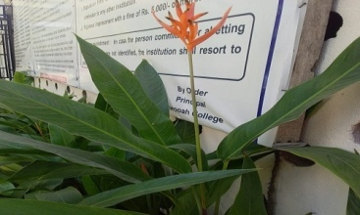
Family-Heliconiaceae
Botanical name:Heliconia psittacorum L.f.
Synonyms:H. swartziana Roem. Schult. , H.sylvestris(Gleason)L.B.Sm.
Common English name: Parakeet flower
Local name: Chota chirayata (Hindi)
Description of plants:Perennial herb, pseudostem emerge from underground rhizome .Leaves simple,alternate,long petioled and have light green,lanceolate leaf blades. Flowers are clustered above 2 or more coloureful,lanceolate floral bract with waxy boom ; individual flower are 3 inches long , and have 6 fused tepals and dark ringed tip. Fruits fleshy ,rounded ,dark blue coloures
Flowering time: July-Sept ; Fruiting time:Oct-Nov
Part used: Leaves and Flower
Medicinal uses: Leaf juice is used in intestinal pain& jaundice.
Other uses:Ornamental.

Family-Liliaceae
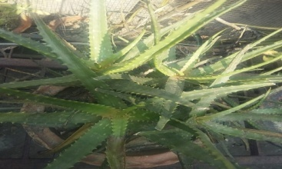
Botanical name: Aloe vera(L.)Burm.f.
Synonyms: A. barbedensis Mill. , A.barbedensis var.chinensis Haw.
Common English name: Aloe vera
Local name:Sal-kuori(Ass.), Ghritakumari(Hindi)
Description of plants:.Succulent perennial herbs.Triangular, sessile stem,shallow root system. Leaves are thick and fleshy, green to grey – green, margin of the leaf serrated. The gel inside leaves is clear , odourless and tasteless. Flower produced in summer a spike, each flower being pendulous, with yellow tubular corolla. Fruit contain many seeds.
Flowering time:July; Fruiting time:August
Part used: Leaf Sap
Medicinal uses:Leaf sapheals burns,improves digestive health.
Other uses:Sap is edible.
Botanical name: Chlorophytum comosum(Thunb.)Jacques
Synonyms: Anthericum comosum Thunb.,A. longituberosum Poelln.
Common English name: Spider plant
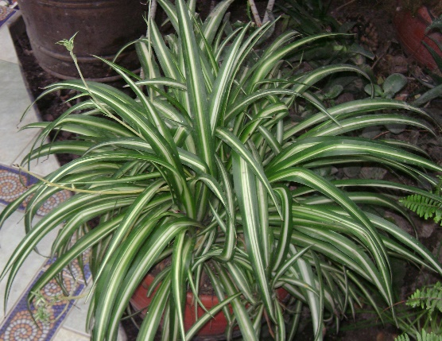
Local name: Musli(Hindi)
Description of plants:.Perennial evergreen herbs .Leaves liniear grow in dense basal rosette,are bright green ,smooth with a prominent mid vein and channeled , end in a soft point , margins are sheathing at the base.Inflorescence is lax, longer than the leaves, aise from the centre of the rosette and is up to 1 m long. .Flower initially occur in clusters of 1-6 interves along the stem of the intervels; individual flower are greenish – white , borne on stalks.Each flower six triply veined tepals,long and slightly boat shaped at their tips .Stamen ,filament long.Style is long.Fruit capsule
Flowering time: April-June; Fruiting time:May-July
Part used: Root
Medicinal uses:Roots is used in treatment of bronchitis & burn.
Other uses:Ornamental

Botanical name: Dracaena reflexa Lam.
Synonyms: Lomatophyllum reflexum(Lam.)Bojer , Pleomele reflexa(Lam.)N.E.Br.
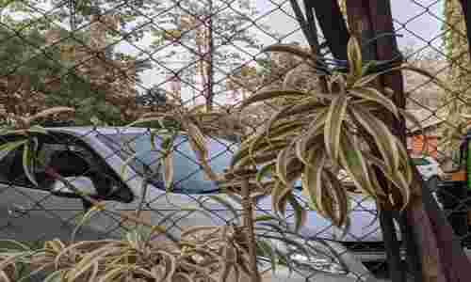
Common English name:Song of India
Local name:
Description of plants:.Shrub, it is slow in growing. Leaves are simple lanceolate ,sprillay arranged,5-20 cm long and 1.5 – 5 cm broad,with parallel veneation and entire margin,grow in tight whorls , uniform dark green. Flowers small ,clustered,usually white in fragnant , tubular .Fruit berry ,dark red.
Flowering time: June-July ; Fruiting time:Aug-Sept
Part used: Leaves
Medicinal uses:Laef extract cures malaria, dysentery& diaarhoea
Other uses:Ornamental

Family- Ponteridaceae
Botanical name:Eichhornia crassipes(Mart.)Solms
Synonyms: E. crassicaulis Schltdl. , Kunth,nom.superfl.
Common English name:Water hyacinth
Local name:Pani meteka(Ass.), Kochuripana(Beng.), Jal kumbhi (Hindi)
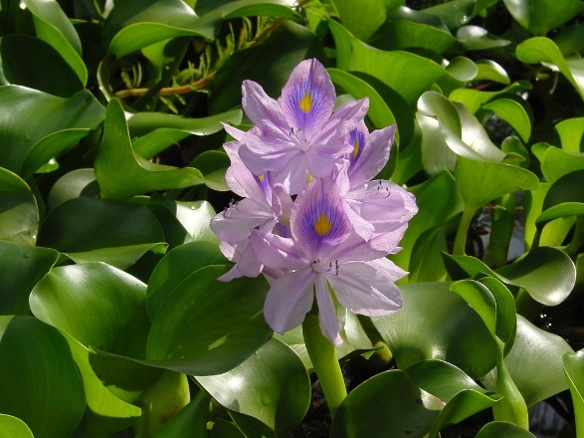
Description of plants:.Aquatic herb, with short stem and many long fibrous roots, floating or sometimes rooting. Leaves glabrous, broadly ovate to rhomboid . Petiole glabrous and spongy , with a fusiform bulbous portion about the middle. Peduncle spongy. Inflorescence 6-15 flowered. Flowers lilac, tinged blue, withering soon. Perianth long, tube green, glandular; segments long, obovate to ovate-oblong, posterior segment with a yellow spot . 3 stamens , filaments curved, glandular hairy ; anthers purple-blue. Ovary ovoid, glabrous; style glandular; stigma 3-lobed.
Flowering time: June-Aug; Fruiting time:Sept-Oct
Part used: Stems
Medicinal uses:Plant extract is used to treat cholera, snake bites, sore throat.
Other uses:Stem used as a braiding material & a source of fibre.

Family- Commelinaceae
Botanical name: Tradescantia spathacea Sw.
Synonyms:T. discolor var. variegata Hook. , T. versicolor Salisb.
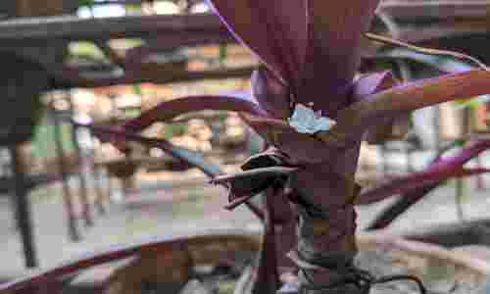
Common English name: Boat lily
Local name:
Description of plants:Short stemed low herb . Leaves densely imbricated,long ,narrow – lanceolate, base vaginate , steel blue and red – brown or purplish below. Inflorescence umbel .Flowers many in a dense umbel , enclosed by 2 boat shaped brcts , white . Sepals 3 , ovate – lanceolate , petals 3 , ovate withering. Stamen 6 ,fertile .Ovary superior , 3 celled with 1 ovule in each cell .Fruit capsule.
Flowering time: March-April; Fruiting time:May-June
Part used:Leaves
Medicinal uses:Leaf extract is used to treat fever, cough, headache .
Other uses:Ornamental

Family-Arecaceae
Botanical name: Cocus nucifera L.
Synonyms: C. indicaRoyle ,C.mamillaris Blanco
Common English name: Coconut
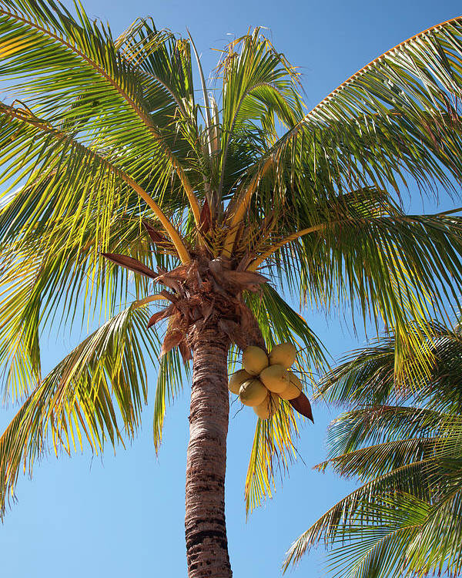
Local name:Narikol (Ass.), Narkel (Beng.), Nariyel (Hindi)
Description of plants:.Erect tree, with annular and petiolar scars . Leaves 4-6 m long , leaflet reduplicate , base narrow , apex tapering acute . Inflorescence is enclosed in a double sheath or spathe , structure known as spadix. Flower monoceious , subsessile , male flower often paired , to 8 mm long ,sepals 3mm long , ovate , petals 6-8 mm long , ovate , woody , yellowish brown , stamen 6 , pistillode short . Female flower 1-3 per branch ,basal globose , perianth lobes 6 , woody , outer lobes broadly obovate , 2 cm across , inner lobes reniforms to 2 cm across . Ovary 3- celled , ovule 1 per cell , style short .Fruit drupe to 30 cm long ovoid or globose , trignous
Flowering time: June-July ; Fruiting time:July-Nov
Part used:Fruit
Medicinal uses:Coconut is taken by mouth for bladder stones , diabetes
Other uses:Coconut oil is used in cooking and as hair oil.

Botanical name:Dypsis lutescens (H.Wendl.)Beentje & J. Dransf.
Synonyms: Areca flavescens Voss , Chrysalidocarpus lutescens H. Wendl.
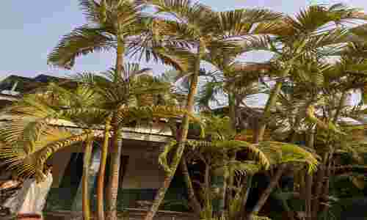
Common English name: Areca palm
Local name: Mamoi tamul (Ass.)
Description of plants:.A small palm ,possesess few stems from the base . Stems bamboo like , slender. Leaves pinnate, arched with 40 – 60 pairs of leaflet. Inflorescence axillary panicles .Flower small , white . Fruit purple or orange, 2 cm long.
Flowering time: April-May; Fruiting time:May-June
Part used: Whole plant
Medicinal uses:It absorbs harmful gases
Other uses:Ornamental

Botanical name:Roystonea regia(Kunth) O.F. Cook .
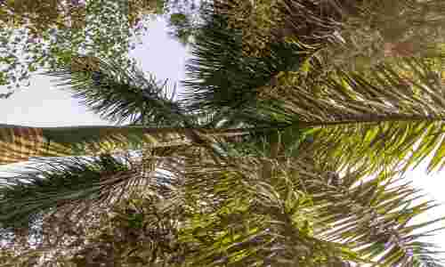
Synonyms:R. regia var. hondurensis P.H. Allen,R, ventricosa (C.H. wright) L H. Bailey
Common English name: Royal palm tree
Local name:
Description of plants:Large palm which reaches a height 20 to 30 m, stem diameter 47 cm. Trunk is stout , very smooth & grey white coloure , 15 leaves . Flower are white with pinkish anthers .Fruit spheroid to ellipsoid in shape.
Flowering time:Aug-Sept; Fruiting time:Nov-Dec
Part used: Seeds
Medicinal uses:Seed is used as source of oil
Other uses:Ornamental

Botanical name: Areca catechu L.
Synonyms: A. catechu var alba Blume, A.catechu var batanensis Becc.
Common English name:Beetel nut
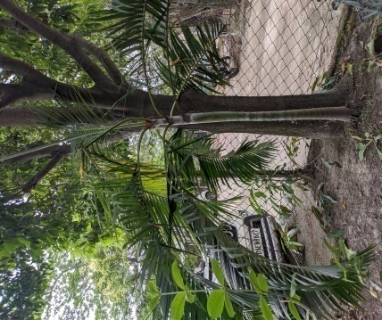
Local name: Tamul (Ass.), Supari (Beng., Hindi)
Description of plants:.Stem erect, hooped, unarmed. Leaves in a terminal crown, to 2 m long; leaflets many, linear or linear-lanceolate, base narrow, apex praemorse; lower ones plicate; upper ones coherent, nerves 2-5 or more, prominent. Spadices several on the axils of fallen leaves, to 50 cm long, branched, shortly peduncled; spikes flexuous or straight, to 30 cm long. Spathes boat-like, coriaceous.Flowers dioceious. Male flowers: c. 3 mm long; sepals 3, c. 1 mm long, triangular; petals 3, c. 2.5 mm, ovate, white; stamens 6; pistillode 2-fid. Female flowers: c. 1.3 cm long; sepals c. 7 mm, obovate; petals to 1 cm; ovary to 8 mm, oblong, 1-celled, ovule solitary. Fruit to 4 x 2.5 cm, with fibrous mesocarps, orange-red in colour.
Flowering time: March-April ; Fruiting time:May-June
Part used: Seeds
Medicinal uses:Areca is used for treatment of a mental disorder called schizophrenia.
Other uses:Nut is chewed with Beetel leaves as mouth freshner.

Family-Araceae
Botanical name: Syngonium podophyllum Schott.

Synonyms: Syngonium podophyllum var. typicum Engl.
Common English name: Arrowhead plant
Local name:
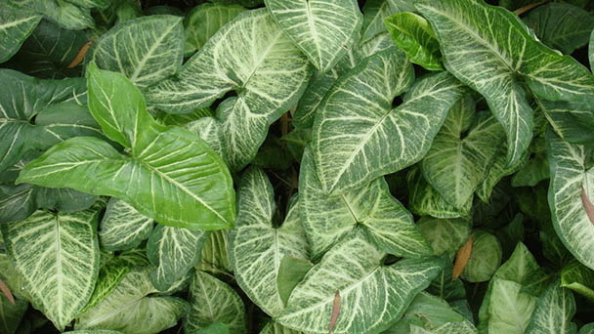
Description of plants:Evergreen climber, plant grow up to 30 cm . Leaves are ovate and heart shaped bases and sometimes with silver variegation .Tiny green to greenish - white flowers on a spadix are surrounded by a greenish - white spathe. Flowers are born in group leaf axils. It gives rise brown black berries.
Flowering time: June-July; Fruiting time:Aug-Sept
Part used: Root
Medicinal uses:Root and bark antibacterial & inflammatory.
Other uses:Ornamental

Botanical name: Monstera deliciosaLiebm.
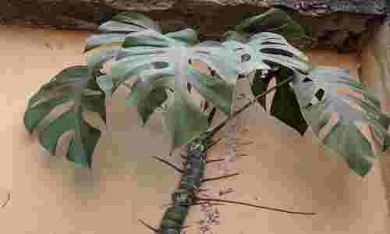
Synonyms: M.borsigiana K.Koch, M.deliciosa var. borsigiana Engl.
Common English name: Swiss cheese plant
Local name: Lata kochu (Ass.)
Description of plants:An epiphyte with aerial root ,able to grow 20 m with large leathery ,glossy heart shaped leaves25 to 90 cm. Inflorescence is half oval creamy white spathe with thick 25 cm long spadix in the middle. Fruit is up to 25 cm long and 3-5 cm diam and looks like green ear of maize covered with hexagonal scales
Flowering time: May-June ; Fruiting time:June-July
Part used: Fruit
Medicinal uses:Fruit is very rich in vitamin C, boost the activity of immune system
Other uses:Ornamental

Botanical name:Philodendron bipinnatifidum Schott ex Endl.
Synonyms:P.pygmaeum Chodat & Visher, P. sellum K.koch
Common English name: Lacy tree
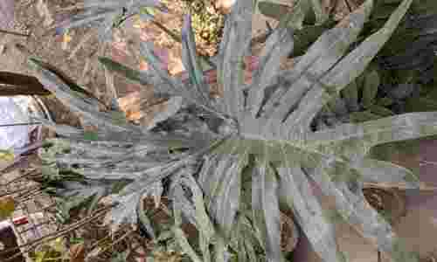
Local name: Philodendron
Description of plants:Epiphytic, stem erect ,decumbent and sparwling or semi erect , branching sparingly is basal parts ; adventitious roots dimorphicin epiphytic plant , anchor root smaller diameter . Leaves are simple , largle deeply lobed & usually drooping can grow up to 1.5 meter& are attached to long smooth petioles, deep green in coloure; leaf blade usually bippinaified . Trunk is relatively thick and woody with characterstics eye drop leaf scars. The small petalless flowers are on a spadix that is enclosed in spathe.
Flowering time: June ; Fruiting time:July
Part used: Roots
Medicinal uses:Roots are used as a diuretic.
Other uses:Ornamental.

Botanical name: Diffenbachia seguine (Jacq.)Schott
Synonyms: D. wallisii Linden ,Segunium maculatum (G.Lodd.)Raf
Common English name: Dumb cane
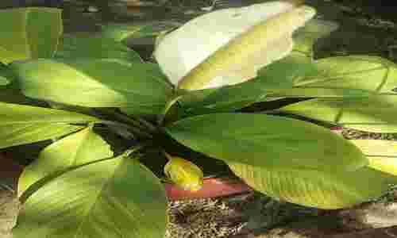
Local name: Tora kosu (Ass.)
Description of plants:.Terrestrial herbaceous plant, stem thick and roots at the nodes.Leaves and stem contain sap. Leaves elongated, grooved and petioles,usually medium green but may be spoted .Flowers are spathe and spadix with 1-4 inflorescence per axil. The spadix is slightly shorter than the spathe and is divided into pistillate and staminate portions with the pistilate flower basal.Flowers nacked, unisexcual. Fruit red or orange
Flowering time: March-Sept; Fruiting time:Sept-Nov
Part used: Whole plant
Medicinal uses:The sap used against the snake bite.
Other uses:Ornamental

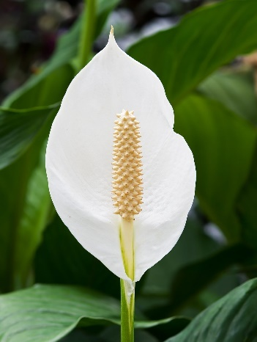
Botanical name: Spathiphyllum wallisii Regel
Synonyms: No synonym recorded
Common English name: Peace lily
Local name: Bagakosu(Ass.)
Description of plants:.Evergreen herbaceous perennial plant . Large leaves 12 – 65 cm long and 3-25 cm broad ; leaves are basal , glossy and somewhat deeply veined , ovate and acuminate; petioles are long. Flowers are produced spadix, surrounded by white ,yellowish or greenish spathe
Flowering time: Feb-March; Fruiting time:April-May
Part used: Whole plant
Medicinal uses:Beauty of the plant relieves stress.
Other uses:Used as ornamental, it also has air purifying properties

Family-Poaceae
Botanical name: Thysanolaena latifolia (Roxb. ex Hornem.)Honda.
Synonyms: T.maxima (Roxb.) Kuntze
Common English name: AsianBroomgrass
Local name: Jharu bon (Ass.), Jharu (Beng.)
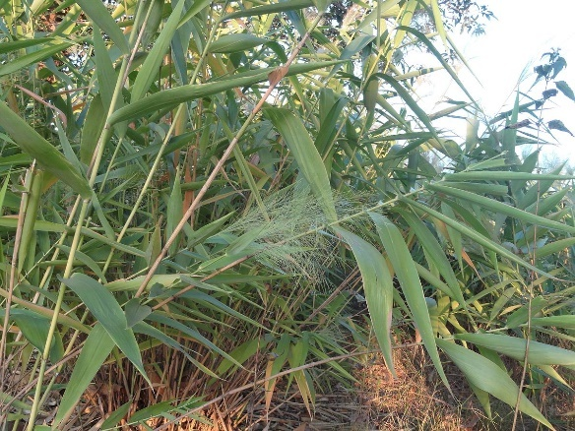
Description of plants:.A Perennial grass culms tall, rounded, hard , glabrous . Leaves numerous , coriaceous , broadly lanceolate , acuminate , sub – amplexicaul , falt , glaucous below , scabrid on the margin , sheaths tight , hard , shining , ligules cartilaginous , very short , truncate . Inflorescence a very soft panicle , glabrous , made up of many erect to sub – erect , filifrom branches , which divide and sub – divide into very numerable , minute spikelets, spikelets 2- flowered , ovoid – lanceolate , acuminate , pedicillate. Fruit caryopsis with adherent pericarp.
Flowering time: Dec-Jan; Fruiting time: Jan-Feb
Part used: Inflorescence
Medicinal uses: The inflorescence paste is used for the treatment of eye infection.
Other uses: Young leaves are used in making brooms.

Botanical name:Cyanodon dactylon (L.)Pers.
Synonyms: Vilfa linearis (Retz.)P.Beauv., Vilfa stellata (Wild.)P.Beauv.
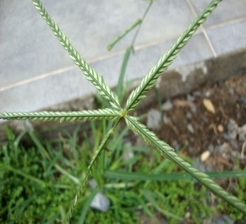
Common English name: Hariali grass
Local name: Dubori bon (Ass.), Durba (Beng.)
Description of plants:.A perennial glabrous grass. Stem slender,prostrate .Leaves narrowly liniear or lanceolate. Usually 3-6 racemes of consists of several (usually 4-5) slender , purplish spikes , arising in a star –like arrangement from the end of stem . Along the underside of the spikes the numerous, sessile spikelets are arranged in two rows each spikelet contains a single floret and there are not bristles .Flowering stems slender and rounded . Fruit caryopsis with adherent pericarp ellipsoid, laterally compressed.
Flowering time: April-June; Fruiting time:June-July
Part used: Whole plant
Medicinal uses:Traditionally it used as a laxative, coolant, expectorant,carminative and as a brain and heart tonic.
Other uses:Used in rituals and ceremonies.

Botanical name: Bambusa vulgaris Schrad.
Synonyms: Bambusa auriculata
Common English name:Golden bamboo
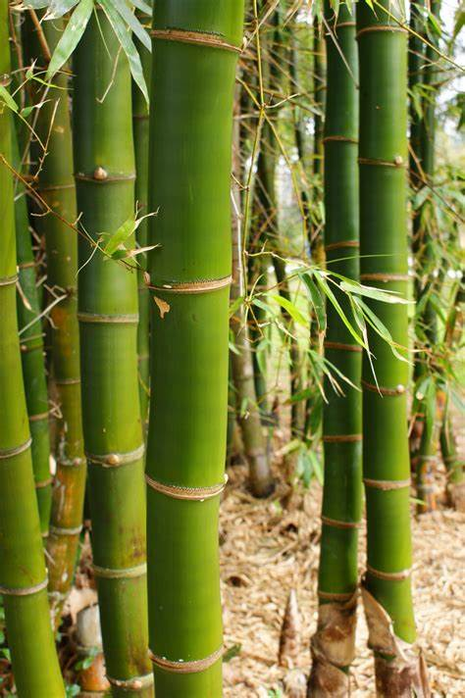
Local name: Tansti baah(Ass.), Baansh (Beng.)
Description of plants:.It has lemon yellow culms with green stripes and dark green leaves. Stems are not straight, not easy to split, inflexible, thick – walled , and initially strong . The densely tufted culms grow 10 – 20 m high and 4 cm thick. Culms are basally straight , drooping at the tips . Culm leaves are deciduous with dense pubescence. Blades are narrowly lanceolate. Flowering is not common and there are no seeds.
Flowering time:; Fruiting time:
Part used: Pseudostem
Medicinal uses:Young shoots are used to treatstomach disorder and fever.
Other uses: Construction of huts and house.

GYMNOSPERMS

Family -Cupressaceae
Botanical name:Thuja occidentalis L.
Synonyms: T. variegata Marshall, T. vervaeneana Van Greet ex Gordon
Common English name: Arborvitae
Local name: Thuja
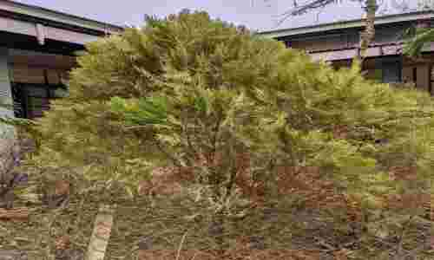
Description of plants:Small or medium size tree, growing to a hight of 15 m .Stem branched, trunk usually short with diffuse branches , bark fibrous ,shedding in long string , buds without bud scales , branches often shedding with age . Bark is red – brown,furrowed and peels in narrow, longitudinal strips . Fan –like branches with scaly leaves. The seed cones are slender, yellow – green, ripening to brown.
Fruiting time:Jan-April
Part used:Leaves
Medicinal uses:Leaves and leaf oil used as a medicine.
Other uses:Ornamental

Family- Cycadaceae
Botanical name: Cycas revoluta Thunb.
Synonyms: C. miquelii Warb. , C. revoluta var. revoluta
Common English name: Sago palm
Local name:Cycas(Ass.)
Description of plants:.Very symmetrical plant support a crown of thiny, dark green leaves as a thick shaggy trunk , bark gray-black, scaly. Leaves 40-100 or more, 1-pinnate, petiole subtetragonal with 6-18 spines along each side; leaf blade oblong- or elliptic-lanceolate, strongly "V"-shaped in cross section, recurved, brown tomentose when young; leaflets in 60-150 pairs, leathery, sparsely pubescent abaxially, base decurrent, margin strongly recurved, apex acuminate, pungent. Pollen cones pale yellow, ovoid-cylindric, microsporophylls narrowly cuneate, apex rounded-truncate, cuspidate. Megasporophylls yellow to pale brown; Seeds 2(-5), orange to red, obovoid or ellipsoid, somewhat compressed, sparsely hairy
Fruiting time:Dec-April
Part used: Seeds
Medicinal uses:Cycad seeds used for treatment of high blood pressure.
Other uses:Ornamental

Family- Zamiaceae
Botanical name: Zamia furfuracea L. f.
Synonyms: Z. crassifolia Hort ex J. Schust., Z.furfuracea var. trewii A.
Common English name: Cardboard sago
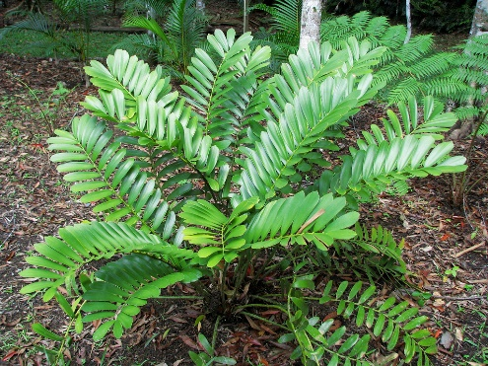
Local name:
Description of plants:Fern like plant with rhizome or palm like plants with unbranched stem, plant dioceoius .Roots adventitious,large fleshy,give corroloid apperance. Stem unbranched, covered with persistant leaf bases. Leaves large,thick,leathery and compound forming a crown at the apex. Microsporophylls aggregated into a compact strobilus; microsporangia born on abaxial side. Megasporophyll aggrecated into strobilus densly crowded, valvate or imbricate, each with 2 ovules. Seeds large.
Fruiting time:Jan-April
Part used:Seeds
Medicinal uses:
Other uses:It is used for the production of sago starch.

Pteridophytes

Family-Selaginellaceae
Botanical name: Sellaginella semicordata (Wall.ex Hook &Grev.)Spring
Synonyms: Lycopodium semicordatum Wall. Ex Hook.& Grev. , S. mettenii A. Braun
Common English name: Spike moss
Local name:
Description of plants:.Terrestrial perennial plants, stem creeping ,slender. Main stem ,branched throughout,arise alternately from base of plant,branches short,pinnately,flabellataer,distant located.Axillary leaves oblong – lanceolate ,base rounded-cuneate,apex truncated;on branches ,obovate.Ventral leaves oblong- lanceolate,rounded at the base,acroscopic base slightly enlarged,not overlapping stem and branches, margin in apex part suberose.Dorsal leaves imbricate. Strobili solitary ,terminal ,tetra gonal. Sporophylls monosporic, ovate, keeled,margin entire,apex acute.Megaspore dark brown.
Flowering time:; Fruiting time:
Part used: Whole plant
Medicinal uses:Plant decoction is used in treatment of traumatic bleeding , gastrointestinal bleeding.
Other uses:Ornamental
Family-Pteridaceae
Botanical name: Pteris vittata L.
Synonyms: P. costataBory ,P. diversifolia Sw.
Common English name: Ladder brake
Local name:
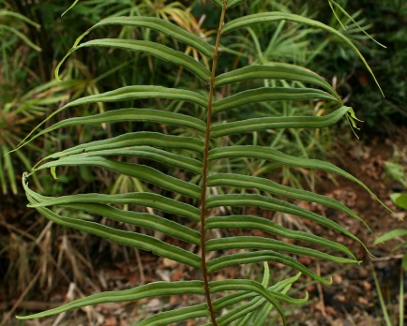
Description of plants:.Herbaceous fern .Stems stout ,short – creeping ,densly scaly , scales pale brown.Fronds clustered ;petiole green to pale brown,densely scaly . Scales dense proximally , extending to and long rachis.Blade oblanceolate .1 – pinnate,rachis not winged. Sporangia homosporous , leptasporangiate , arranged in sori on abaxia surface of leaf margin , forming a continuous band and protected by reflexed leaf margin forming false indusium.
Flowering time:; Fruiting time:
Part used: Whole plant
Medicinal uses:The plant extract is used in development of health products for ageing and chronic diseases.
Other uses:Ornamental

Botanical name: Adiantum capillus – veneris L.
Synonyms:A. tenerum var. dissectum M.Martens &Galeoti ,A. trifidum Wild. Ex Bolle
Common English name: Maiden hair fern
Local name:
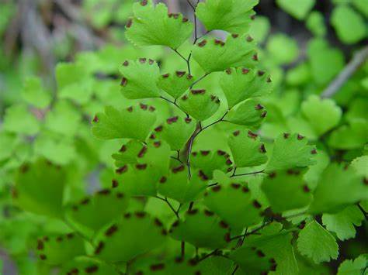
Description of plants: Deciduous perennial fern consists of a much – branched bipinnate leaf and. in outline, this leaf is renifrom or fan – shaped in outline it has pinnae radiating in all directions. The petiole is black or dark brow, wiry glabrous, and erect. The petiole divides into two major branches that widely diverge from each other. Along one side of each branch, there are several straight pinnae are up to 12 long and 2 across they have 4-24 pairs of leaflets and single terminal leaflets. The central stalks of the pinnae are blackor dark. The non terminal leaflets are arranged alternately to nearly opposite along each stalk on short petiolules they are medium green and glabrous.
Flowering time:; Fruiting time:
Part used: Leaf Fronds
Medicinal uses:
Other uses: Fronds are used as a garnish on sweet dishes
REFERENCES

B. Parthipan ,R. M, J. Solomon (2016) Floristic Diversity Of South Travancore Hindu College(S.T. Hindu College) Campus, Kanyakumar District(TamilNadu)India(Bioscience Discovery)7(1):41-56

Gogoi Khyanjeet (2012) A checklist of orchids in Tinsukia District of Assam , India in Pleione,6(1) : 5 – 26

K.Surender , D. Sunita , Laura J.S. , Singh Narender , Kudesia Rajdeep. (2016) Phyto- diversity on campus of K.M.Goverment Colllege ,Narwana India (Intertional Journal ofCurrent Microbiology & Applied sciences) Volume 5 number 7 , pp.565-570

Kar A. , Borthakur S. K. (2007) Angiospermic Flora of Gauhati University Campus , Assam , India 1(2): 26 – 37 . 2007.(East Himalayan Society for Spermatophyte Taxonomy)

Nath S. K. (2015) FLORISTIC DIVERSITY OF NAGAON DISTRICT OF ASSAM , INDIA , Vol no 4 , special issue No. 01 (International journal of Science Technology & Management)

Parani k , Alagushathi A, Gayathri S and Anusiya K.(2016) , Floral diversity on campus of Sri Parasakthi College ,Courtallam ,Tamil Naidu,India , (International Peer ReviwedOpen Access Refereed Journal) 7(1): 92-98

Rajendran A ,Aravindhan , V. and Sarvalingam,A. (2014) biodiversity of the Bharathiar university campus India ;A floristic approach (International Journal of Biodiversityapproach) Vol.6(4),pp.308-319

Savina, L.Amit,K. Manoj(2018)STUDY OF PLANT DIVERSITY OF BHAGAT PHOOL SINGH MAHILA VISHWAVIDYALAYA KHANPUR KALAN ,DISTRICT SONIPAT , HARIYANA , INDIA(www.jetir.org)Volume5,issue6)

Books
Barua Akhil , Morphology and Taxonomy of Angiosperm

Hooker J.D. (1872- 97)FLORA OF BRITISH INDIA.L.Reeve & Co.London, Vol.1-7

Kanjilal U.N. ,Kanjilal ,P. C. and Das , A. 1934 – 1940.Flora of Assam Vol.1-4(Govt.of Assam ,Shillong

Mondal A.K. , Advanced Plant Taxonomy

Sharma O. P.,Plant taxonomy ,Second Edition

Singh Gurucharan,Plant Systematics

Website
http://indiabiodiversity.org
http://inwikipediaorg/wiki/plant description
http://ww.missouribotanicalgarden.org
http://www.efloraofgaandhinagar.in
http://wwwresearchgate.net
http://feedipedia.org
http://www.plantsworldonline.org/taxon
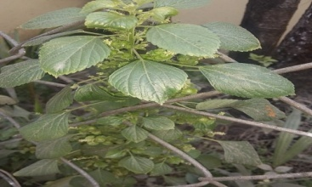
P.fruticosa (L.)Harms A. indica L. Bixa orellana L.

A.conyzoides(L.)L. A.vera (L.)Burm.f. B.pinnatum(Lam.)
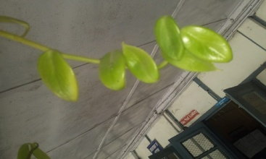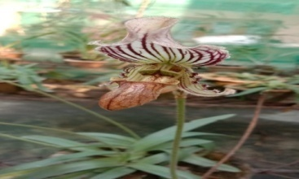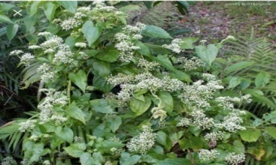
P.serpens(Sw.)Loudan P. farrieanum(Lind.)Stein Mikania micrantha

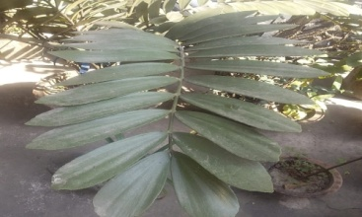
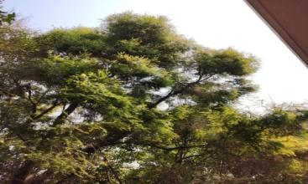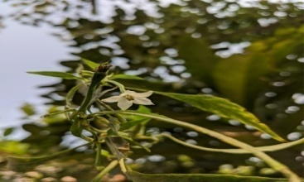
C. citrinus (Curtis)Skeels C. annum L.

